BOROUGH OF KENILWORTH

MASTER PLAN

February 2011

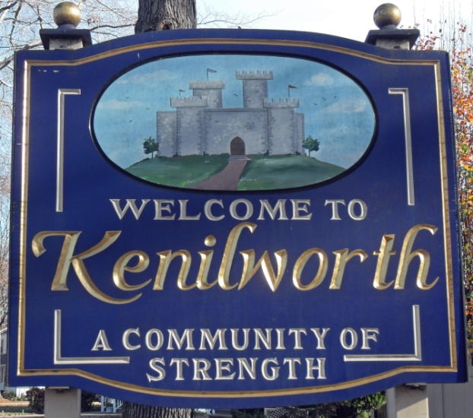

PLANNING BOARD – 2010 - 2011

Anthony Lepore, Chair
Richard Picerno, Vice Chair
Madonna Bogus, Secretary
Kathi Fiamingo, Mayor
Sal Candarella, Councilman
Rudy Cammarota, Mayor’s Designee
Antonio Cuppari, Class IV - 2011
Nicholas Pantina, Class IV - 2010
Anthony Pugliese, Class IV
Marty Sica, Class IV
Antonio Cuppari, Alternate - 2010
Arthur Manee, Alternate
Timothy Murphy, Alternate

MASTER PLAN SUBCOMMITTEE
Anthony Lepore, Chair
John Beninati
Sal Candarella
Regina Hrynkiewicz
Fred Pugliese

MAYOR – 2010 - 2011
Kathi Fiamingo

BOROUGH COUNCIL – 2010 - 2011
Brian Joho, President - 2010
Sal Candarella
Peter Corvelli - 2011
Scott Klinder
Kevin Leary, President - 2011
Fred Pugliese
Toncia Sosnosky - 2010

STAFF
Hedy Lipke, Borough Clerk
Kathleen Moschitta, Deputy Clerk
Ellen Johns – Planning Administrator
Harvey Fruchter, Esq. – Borough Attorney
Richard O’Connor, P.E. – Borough Engineer
Kevin O’Brien, P.P. – Borough Planner
Michael Tripodi, Esq. – Board Attorney
Janet Murphy – Board Recording Secretary

The Master Plan Subcommittee and the Planning Board acknowledge with thanks and gratitude the municipal agencies, officials, employees and volunteers who gave willingly of their time and expertise.

Prepared by:
Kevin O’Brien, NJ P.P. License 5348
Shamrock Enterprises, Ltd.
Rahway, NJ 07065 732/388-4765
Richard O’Connor, NJ P.E. License 33029, NJ P.P. License 4254
Edward Bogan NJ P.E. License 22260, NJ P.P. License 1662
Grotto Engineering Associates
Cranford, NJ, 07016 908/272-8901

The original of this document was signed and sealed in accordance with N.J.A.C.
13:41-1.3(b) and is on file with the Borough of Kenilworth Planning Board.

input.doc

RESOLUTION OF THE PLANNING BOARD OF THE BOROUGH OF KENILWORTH, UNION COUNTY, NEW JERSEY, ADOPTING THE “BOROUGH OF KENILWORTH MASTER PLAN” DATED FEBRUARY 24, 2011

WHEREAS, N.J.S.A. 40:55D-28 authorizes a municipal planning board to prepare and, after public hearing, adopt or amend a master plan or components thereof; and

WHEREAS, the Planning Board of the Borough of Kenilworth, Union County, State of New Jersey (the “Planning Board”), adopted the Borough’s current Master Plan in 1996, which was subsequently readopted and reexamined by the Planning Board; and

WHEREAS, during 2009, the Planning Board determined that the Master Plan required a comprehensive review and revision in its entirety; and

WHEREAS, the Planning Board prepared a new Master Plan entitled, “Borough of Kenilworth Master Plan” dated February 24, 2011 with the assistance of Borough Planner Kevin O’Brien and Borough Engineer Richard O’Connor which has been the subject of discussion at six (6) public meetings of the Planning Board; and

WHEREAS, a subcommittee was appointed to assist with the preparation of the Master Plan, which included having six (6) meetings and performing numerous specific tasks to prepare the Master Plan; and

WHEREAS, the Master Plan includes a Land Use Element pursuant to N.J.S.A. 40:55D-28b (3) and a Housing Element pursuant to N.J.S.A. 40:55D-28b (3); and

WHEREAS, the Planning Board had a public meeting on December 2, 2010 to allow the public input on the proposed Master Plan; and

WHEREAS, upon notice duly provided pursuant to N.J.S.A. 40:55D-13, the Board scheduled public hearings on December 16, 2010 and February 24, 2011 for the proposed Master Plan; and

WHEREAS, the Planning Board heard evidence from Borough Planner Kevin O’Brien and Borough Engineer Richard O’Connor in connection with the proposed Master Plan at the December 16, 2010 and February 24, 2011 public hearings; and

WHEREAS, the Planning Board provided the general public an opportunity to comment on the proposed Master Plan at the December 16, 2010 and February 24, 2011 public hearings; and
WHEREAS, at the conclusion of the public hearing, a motion to adopt the Master Plan was made, seconded and voted upon by the members of the Planning Board.

TABLE OF CONTENTS

Land Use Element of the Master Plan 7

I. Introduction to the Land Use Element 8
II. Overview of Kenilworth 9
III. Demographic Analysis 11
IV. The Master Plan 18
V. Goals and Objectives 22
VI. Existing Land Use and Zoning 26
VII. Proposed Land Use Zones 35
VIII. Proposed Zoning Strategies 41

Housing Element of the Master Plan 46
I. Introduction to the Housing Element 47
II. Organization of This Element 48
III. Housing Objectives 48
IV. Municipal Land Use Law Required Components 49
V. Conclusion 63

Statement of Plan Relationships 64
I. Introduction 65
II. Analysis of Surrounding Communities 65
III. Union County Plan 66
IV. Solid Waste Management Plan 67
V. The State Development and Redevelopment Plan 68
Appendix 1 Demographic Profile 69
Appendix 2 Maps 75

LAND USE ELEMENT OF THE MASTER PLAN

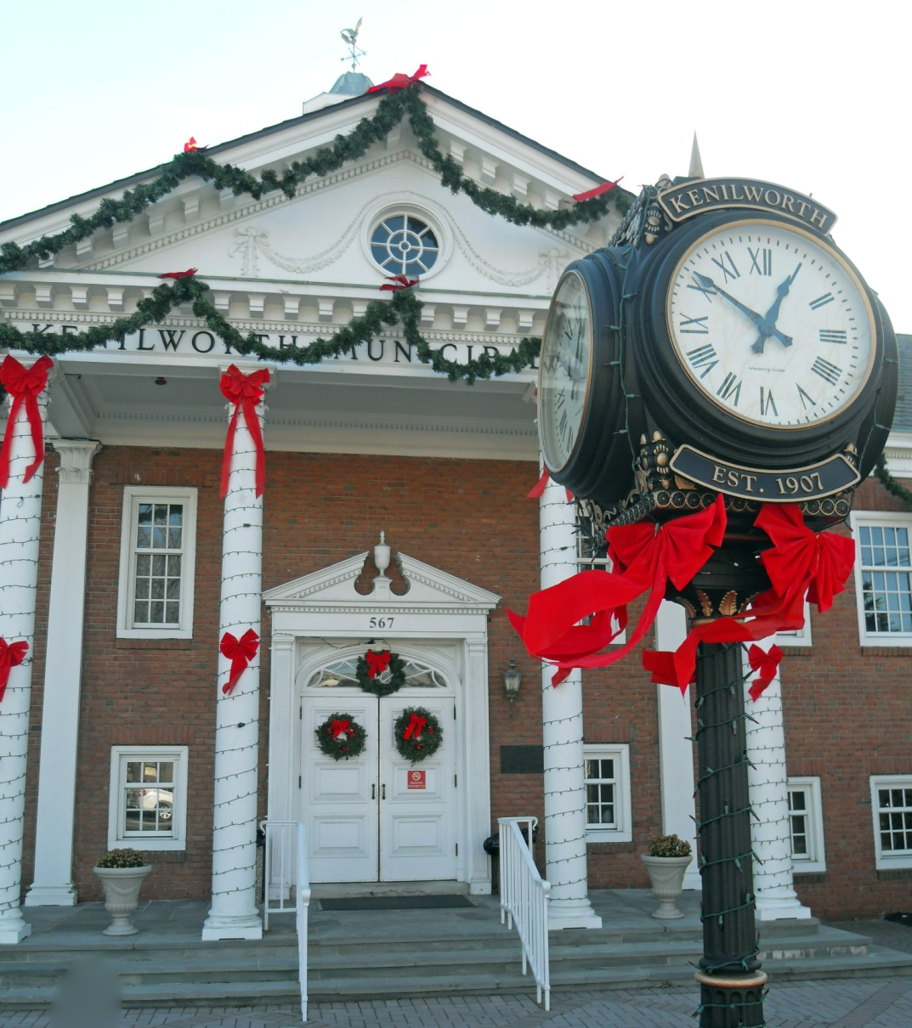

I. INTRODUCTION TO THE LAND USE ELEMENT

The people of Kenilworth love their community. One can see this love at the Annual Street Fair on the Boulevard, at Little League or soccer games, at Brearley football games, at gatherings at the historic Nitschke House, the Veterans Center and many other community events.
This love for community is evident in the pride visible in the community in residential areas and storefronts along the Boulevard. It is also evident in the participation of citizens in community activities, such as the Fire Department, the Rescue Squad, Borough Boards, government bodies and numerous community organizations.
Kenilworth is a town where young adults live in the same neighborhoods as their parents and grandparents. It’s a community where everyone knows someone from your family. It is that love for community and pride in Kenilworth that led the Borough to write this Master Plan for our community.
The days of large manufacturers producing heavy industrial equipment in factories that provided high paying steady employment within walking distance of cohesive family oriented neighborhoods are in the past. The Kenilworth that existed during World War II and the following golden years is no more.
Today Kenilworth is dealing with the economic reality of major global changes including a declining industrial base and loss of good paying blue collar occupations. As a result the industrial areas of the community are in decline while the residential areas are thriving.
This Master Plan has been written to propose changes to our community that reflect the world that we live in. It is our hope that our pride in Kenilworth will continue as we make changes to improve our community and to pass along the Kenilworth that we love to future generations.



II. OVERVIEW OF KENILWORTH

The Borough of Kenilworth is 2.08 square miles in area and is located in the center of Union County, bordering Union Township, the Borough of Roselle Park, Cranford Township and Springfield Township.
In 2000 there were 7,675 people and 2,117 families in Kenilworth. There were 2,926 housing units and 2,854 households in the Borough of which 28.6% had children under the age of 18 living with them, 58.4% were married couples living together, 11.9% had a female householder with no husband present, and 25.8% were non-families. 21.4% of all households were made up of individuals and 11.0% had someone living alone who was 65 years of age or older. The average household size was 2.69 persons and the average family size was 3.15 persons.
The Borough’s population included 20.8% under the age of 18, 6.9% from 18 to 24, 30.8% from 25 to 44, 23.3% from 45 to 64, and 18.2% who were 65 years of age or older. The median age was 40 years.
The median income for a household in the Borough was $59,929, and the median income for a family was $66,500. The per capita income for the Borough was $24,343. About 1.9% of families and 2.0% of the population were below the poverty line, including 2.2% of those under age 18 and 3.2% of those aged 65 or over.
The 2006 US Census estimated that there were 7,741 people in the Borough, an increase of 66 people over the 2000 Census.
Kenilworth is a mature suburb in the New York City Metropolitan area. It is accessible via the Garden State Parkway and US Route 22. Kenilworth Boulevard (Union County Route 509) provides a major east west route between Elizabeth and Westfield/Springfield.

A. History of Kenilworth
Kenilworth’s roots can be traced to a pre-Revolutionary farming community which was acquired in the late 1800s by a group of real estate developers who initially called the town New Orange. The area was renamed Kenilworth, after England’s Kenilworth Castle and Sir Walter Scott’s novel, Kenilworth, and in 1907 was incorporated as the Borough of Kenilworth.
Kenilworth was once home to such institutions as Upsala College and Kensington Riding Academy. Kenilworth has attracted a number of famous visitors over the years, including inventor Thomas A. Edison and renowned aviator Gen. James Doolittle, who crashed his experimental plane in Kenilworth in 1929 while attempting an emergency landing in foggy conditions. Doolittle credited the accident with reinforcing his commitment to developing blind-landing instrumentation for all-weather flying, one of his most significant aeronautical achievements.
The Oswald J. Nitschke House (c. 1880), one of Kenilworth’s few remaining 19th-century farmhouses, is an important focal point for interpreting the community’s rich history and serves as a significant venue for heritage tourism. The Kenilworth Historical Society saved the historic home of local pioneer and former Mayor Oswald Nitschke from demolition by relocating it in 2003 and undertaking its restoration and transformation into a “living history” museum and cultural arts center. The Nitschke House is listed in the New Jersey and National Registers of Historic Places.
Kenilworth’s growth and development over the years may be attributed in large part to the industrial strength and notable corporate citizenship of local businesses. The Borough currently is home to many thriving companies, including the worldwide pharmaceutical firm Merck (formerly Schering-Plough Corporation, which for many years was based in Kenilworth).

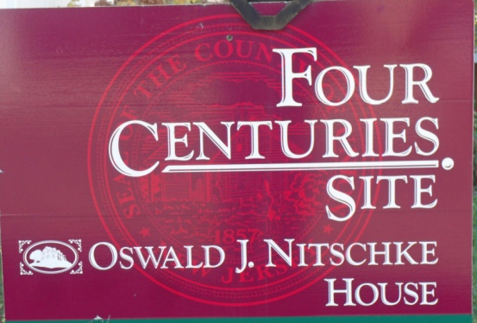

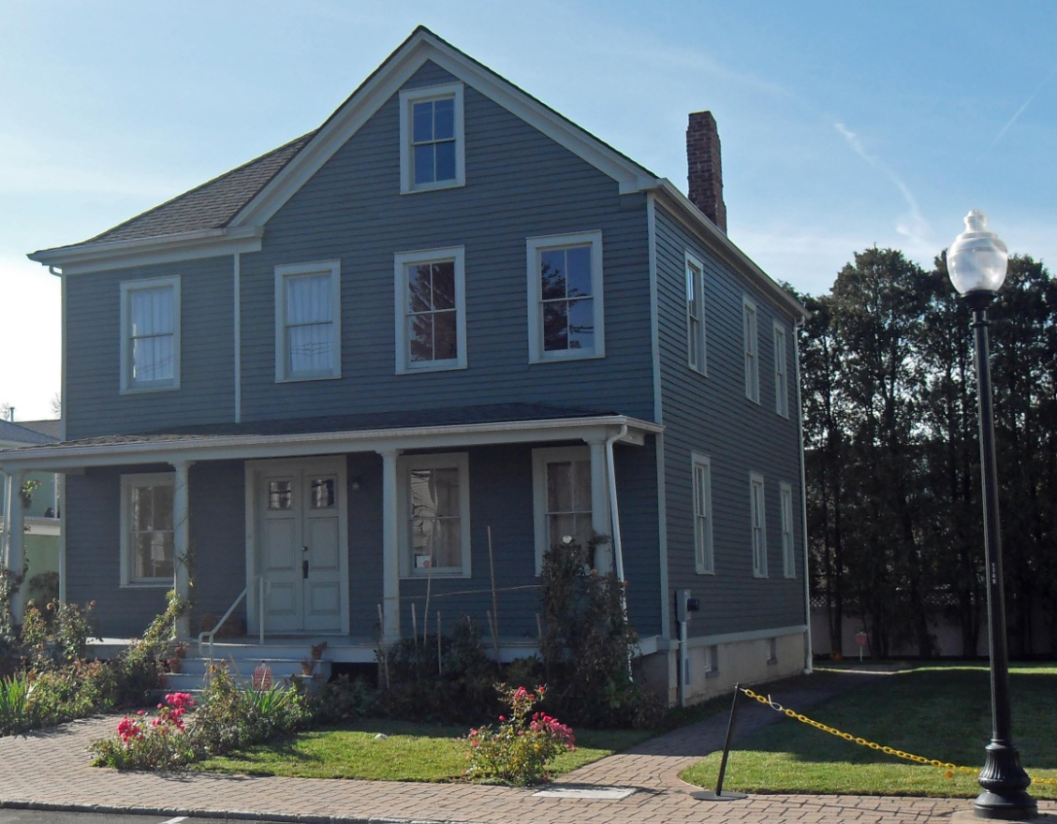

III. DEMOGRAPHIC ANALYSIS

This section of the Master Plan discusses the demographic conditions of Kenilworth by analyzing the results of the 2000 US Census of Housing and Population for variety of social and economic factors. The analysis provides an overview of demographic and economic conditions in existence in 2000. While the information is dated, it is helpful in considering the current status of the Borough’s economic health.

All of the data below is based upon the Demographic Profile of Kenilworth in Appendix 1, which is based on the 2000 US Census and the 2003 Kenilworth Smart Growth Plan. While the 2010 Census data is expected to be substantially similar to the enclosed information, it is the intention of the Planning Board to update this Master Plan with Census generated data when it is available later in 2011.

A. Population
Kenilworth is a fully developed suburban community. Between 1980 and 1990 the population of Kenilworth dropped from 8,221 to 7,574. However in the period between 1990 and 2000, Kenilworth's population increased by 101 persons to 7,675 (See Table 1). During the last twenty years, the age distribution of Kenilworth has shifted significantly. While the population under nine years old has remained between 800 and 900, the population between 10 and 19 has declined from 1364 to 837 and the population between 20 and 34 declined from 1841 to 1489. On the other hand, the population between 35 and 54 has increased from 1905 to 2350. The population over 55 years old has remained relatively constant. The overall result is that Kenilworth is evolving into an older, more mature community.

TABLE I
POPULATION AND AGE DISTRIBUTION OF KENILWORTH –
1980, 1990 AND 2000
Age | 1980 | 1990 | 2000
Under 9 years | 845 | 809 | 890
10 to 19 years | 1,364 | 799 | 837
20 to 34 years | 1,841 | 1,732 | 1,489
35 to 54 years | 1,905 | 1,965 | 2,350
55 years and over | 2,266 | 2,269 | 2,109
Total | 8,221 | 7,574 | 7,675
Source: 1980, 1990 and 2000 US Census of Population and Housing

This aging trend is even more pronounced when Kenilworth's population is compared to the population of Union County as well as the State of New Jersey (See Appendix 1 - Demographic Profile of Kenilworth). Kenilworth's population is relatively or proportionately smaller in all age groups from under 5 to 24 years old and proportionately larger in all age groups over 45 years old.

TABLE 2 – POPULATION SINCE 1930
YEAR | POPULATION | NUMBER CHANGE | % CHANGE
1930 | 2,243
1940 | 2,451 | +208 | 9.27%
1950 | 4,922 | +2,471 | 100.81%
1960 | 8,379 | +3,457 | 70.23%
1970 | 9,165 | +789 | 9.41%
1980 | 8,221 | -944 | -10.30%
1990 | 7,574 | -647 | - 7.87%
2000 | 7,675 | +101 | 1.33%
2006 | 7,741 | +66 | 0.85%
Source – US Census Bureau and 1996 Master Plan

As shown in the above Table, population in the Borough has reflected area trends since 1930 and includes, but is not limited to: suburbanization, industrialization, rapid growth, decline and regrowth.
Between 1930 and 1970 the Borough population increased exponentially in size as the Borough was developed with suburban homes resulting from low interest mortgages, the GI Bill and access to industrial and manufacturing jobs. Population decline set in by 1980 as the Borough was developed, leaving little available vacant land for building. Population declined as family size decreased significantly.
Growth since 2000 has been fueled by economic factors, such as the availability of affordable middle class housing within the Borough compared to distant newly developed areas of New Jersey as well as access to employment and a growing trend of young adults to live with parents following completion of college.

B. Race and Ethnicity
Kenilworth is predominantly one race. Whereas 65.5% of Union County is white, 91.3% of Kenilworth is white. All other races including the Hispanic or Latino population are underrepresented in the resident population of Kenilworth in comparison with Union County and the State of New Jersey.
C. Household Types
A higher percentage of Kenilworth households are in married couple households (58.4%) than is the case for the county or the state (52.6% and 53.5% respectively). The percentage of female headed households is lower in Kenilworth (11.9%) than the County (14.2%) or the State (12.8%). In addition, the percentage of non-family households in Kenilworth (25.8%) is lower than the County (28.4%) or State (29.7%) (See the Demographic Profile of Kenilworth).
However, the number of non-family households has greatly increased over the last twenty years from 421 in 1980 to 737 in 2000. Kenilworth remains primarily a traditional married couple community, but gradually Kenilworth is changing as has the rest of the state toward non-traditional household types. In Kenilworth, the most apparent non-traditional household type is that of seniors living alone (11.1%).

TABLE 3
CHANGE IN HOUSEHOLD TYPE IN KENILWORTH
1980, 1990 AND 2000
Households | 1980 | 1990 | 2000
Family | 2,330 | 2,216 | 2,117
Non-Family | 421 | 584 | 737
Total | 2,751 | 2,800 | 2,854
Source: 1980, 1990 and 2000 US Census of Population and Housing

D. Housing Occupancy and Tenure
Kenilworth has a housing stock of approximately 3,000 units. Of these, only 2.5% are vacant, with a vacancy rate two-thirds lower than the State's. In addition, 78.1% of Kenilworth's housing stock is owner occupied. This percentage is significantly higher than Union County (61.5%) and the State of New Jersey (65.6%). Interestingly, the average household size of owner occupied units in Kenilworth (2.73) is small than either the County (2.92) or the State (2.81). This lower household size may reflect the growing number of married couples that are often referred to as empty nesters since there are no children in the household.

E. School Enrollment and Educational Attainment
School enrollments in Kenilworth approximate those of the County and State with three notable exceptions. First, nursery school or pre-school population is higher than the County or State (9.2% of students versus 8.3% and 8.2% respectively). Second, the kindergarten population is much lower than the County and State (3.2% of students versus 5.7% and 5.5% respectively). Lastly, given that Kenilworth is not a college town it is somewhat unexpected that a high percentage of students are attending college or graduate school (22.8%) versus slightly lower figures for the County and State (20.7% and 21.2% respectively). This data suggests that new households with young children are forming or moving to Kenilworth as the older residents leave and reflects the growth in the number of 0 to 9 year old children between 1990 and 2000. The result is a large nursery school and preschool population. The small kindergarten population may be an anomaly or may be the tail end the last generation's child rearing years. The large number of college students may be young adults living in their parent's home while attending school (See Demographic Profile of Kenilworth).
The levels of educational attainment by Kenilworth residents are somewhat lower than that of the County or the State. Only 15.5% of Kenilworth adults have college, graduate or professional degrees, versus the County and State (28.5% and 29.8% respectively). The majority of Kenilworth adults have completed high school and/or attended some college (59.2%). The high percentage of residents who are attending college suggests that a number of these students are the first generation to attend college and that the next generation of Kenilworth residents will be better educated - assuming the current students continue to reside in Kenilworth.

F. Marital Status
The marital status of Kenilworth residents is similar to that of the County and State. However, Kenilworth has a slightly lower percentage of persons who had never married (26.2% versus 29.2% and 28.1% respectively) and a slightly higher percentage of persons who are now married and not separated (55.3% versus 53.4% and 54.6 % respectively). The major differences are that there are relatively fewer persons who are separated in Kenilworth than the County or the State (0.8% versus 2.6% and 2.4% respectively), the percentage of Kenilworth residents who are widowed is higher than that of the County or the State (10.3% versus 7.7% and 7.4% respectively), and the percentage of Kenilworth adults who are divorced is higher than that of the County or the State (7.4% versus 7.1% and 4.5% respectively).

G. Residence in 1995
The residents of Kenilworth are much less likely to have moved in the last five years than residents of the County or the State as a whole. A very high 70.1% of Kenilworth's residents lived in the same house in 2000 as they had lived in 1995. The comparable figure for the County was 60.8% and for the State it was 59.8%.

H. Language Spoken at Home
The percentage of persons in Kenilworth who speak English only in the home is 72.9% which falls between Union County which has a lower number of 68.4% and the State of New Jersey which has a higher number of 74.5%. Of the persons who speak a different language at home, Kenilworth significantly varies from the County and the State. Most non-English speakers are Spanish speakers in both Union County and the State of New Jersey. However, in Kenilworth unspecified other Indo-European languages are more frequently spoken in the home (18.2% of persons versus 6.9% of persons). Given that the 2000 Census reports that 32.9% of Kenilworth residents have Italian ancestry, 17.8% have German ancestry and 13.7% have Polish ancestry, it would appear most likely that one or more of these three groups include a large number of primarily non-English speakers.

I. Employment and Occupation
The labor force participation rate is the percentage of persons over 16 years old and who are either employed or looking for work at that time. The Kenilworth labor participation rate is 64.4% and is within one percentage point of the county and state labor participation rates. In 2000, unemployment in Kenilworth was 2.9% — a rate lower than the County (3.5%) and the State (3.7%).
The occupational distribution of Kenilworth residents differs significantly from Union County and the State. The largest group of Kenilworth workers are involved in sales and office occupations (31.3 %), whereas with the County and the State the largest group was management, professional and related (35.4% and 38% respectively). The next largest group in Kenilworth was management, professional and related (30.5%), followed by service occupations (16.2%), production, transportation and material moving (11.2%) and construction, extraction and maintenance (10.6%). A larger percentage of Kenilworth workers are employed in sales and office, and service and construction occupations than either Countywide or Statewide workers.

J. Commuting to Work
The average travel time to work for Kenilworth based workers is 24.6 minutes — four to six minutes less than either Union County or State residents. Kenilworth workers are more likely to drive alone to work (85.5%) than their County and State counterparts (71.0% and 73.0% respectively), and were less likely to carpool, use public transportation, walk or work at home than County and State workers.

K. Industry and Class of Worker
The Kenilworth workforce is broadly distributed across most industries. The industries with the heaviest concentration of jobs are educational, health and social services (16.8% of the workers) and manufacturing (16.1%). No other industry employs ten percent or more of Kenilworth workers. Industries that employ a larger share at the County and the State level are educational, health, and social services (16.8% versus 18.4% and 19.8% respectively), Retail trade (8.4% versus 10.2% and 11.3%), and professional, scientific, management and administrative (9.7% versus 11.4% and 11.5%).
In Kenilworth, as with Union County and the State of New Jersey, over 80% of all workers are private wage and salary workers. Between 12% and 14% of workers in Kenilworth, Union County and the State of New Jersey work as government employees and between 4.5% and 5.5% of Kenilworth, Union County and State of New Jersey workers are self-employed.

L. Income and Poverty
Kenilworth per capita income in 2000 was $24,343, which was lower than Union County ($26,992) and the State ($27,006). On the other hand the income figure most commonly used by planners and economists is the median household or family income. The median household income for Kenilworth was $59,929 in 2000 and was higher than either the County ($55,339) or the State ($55,146). The median family income in Kenilworth was $66,500 in 2000 and was higher than either the county ($65,234) or the state ($65,370).
The distribution of income for Kenilworth resembles the county and state except that there are a smaller percentage of Kenilworth households and families that make less than $14,999 or more than $150,000. This suggests that Kenilworth is very homogeneous with respect to income class. This finding is further emphasized by the fact that a very low rate of poverty exists in Kenilworth. Whereas 6.3 % of families in the County and the State live in poverty, only 1.9 % of Kenilworth families live in poverty. With individuals, the spread between Kenilworth and the County and State is even greater (2.0% versus 7.6% for both the County and the State).

M. Summary
Kenilworth is a solid, middle class and homogeneous community with a strong work ethic. The community's wage earners appear to be a little older, often in their most productive earning years, and concentrated in manufacturing, retail, transportation and services. Kenilworth residents are more stable with fewer relocations than most communities and more likely to be in married families. The strength of the community is demonstrated by its very low rate of poverty for families and individuals.
The 2010 US Census figures are expected to be substantially similar to the enclosed information. The Great Recession of 2008 has caused significant economic displacement and a reduction in manufacturing and other labor intensive economic activities. While these activities are not expected to return, the Borough has seen an increase in the adaptive reuse of former industrial sites, as well as an increase in employment at several sites.
Kenilworth is expected to remain a strong, thriving community in the foreseeable future as the Borough, and its people, adapt to a new economic reality.

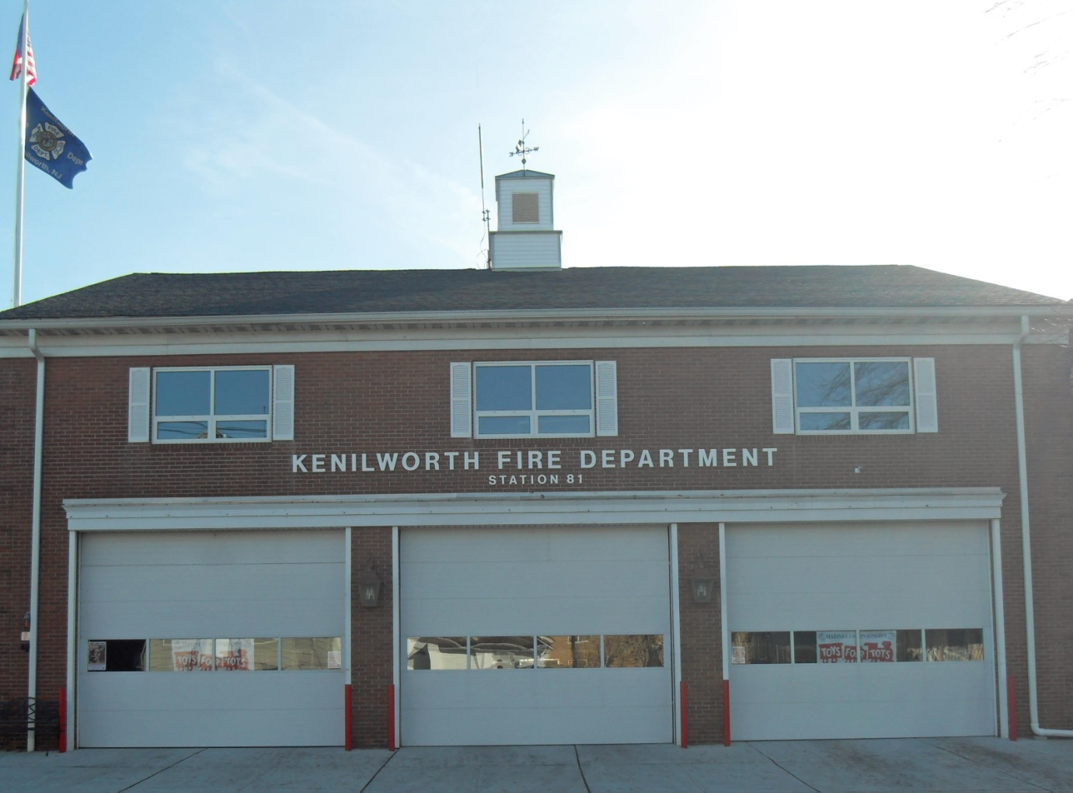

IV. THE MASTER PLAN

The Borough of Kenilworth Master Plan was last adopted in 1996. A Reexamination of the Master Plan was conducted in 2001. Given the changes to the local and national economy, the Mayor, Council and Land Use Board of the Borough embarked upon the Master Plan process. This document will serve as a general guide to the physical, economic and social development of the Borough over the next six years and will promote and protect the public health, safety, morals and general welfare of the Borough.

A. MASTER PLAN PREPARATION
This Master Plan seeks to update planning information in the Borough with regard to demographics, land use, housing and the Plan's relationship to other applicable plans, and includes a Land Use Plan Element, Housing Plan Element, and a comparison of this Master Plan to those of adjacent municipalities, the County and the State Development and Redevelopment Plan (SDRP). The current Borough of Kenilworth Master Plan was adopted in 1996 and was reexamined in 2001. This document serves as an update of the required portions of the municipal Master Plan.
This Master Plan was prepared in accordance with the provisions of the New Jersey Municipal Land Use Law (N.J.S.A. 40:55D-28). The document is designed to guide the development and redevelopment of lands within the Borough in a manner which will promote and protect the public health, safety, morals and general welfare of present and future residents of the Borough.
A comprehensive analysis of local and regional trends as well as an analysis of the physical character of the community was guided by the Master Plan’s public outreach process. The Mayor and Council believe that public involvement is critical to successful planning. As such, the Master Plan provided the community with an opportunity to voice comments on a wide range of issues. The identification of key planning issues facing the Borough was the first step of the Master Planning process. These key issues laid the foundation for the planning basis that established the goals and objectives.
The Master Plan Subcommittee met throughout 2009 and early 2010 and worked tirelessly on the Master Plan process. Additional meetings were held with the Borough Mayor and Council as well as the Planning Board. In addition, public input was solicited at four public hearings where a number of concerned citizens made contributions.

B. THE MASTER PLAN PROCESS
The Master Plan provides a comprehensive guide for the future development and preservation of key areas of a community. The key element in defining the difference between a Master Plan and other planning studies is the Master Plan's comprehensive approach to planning issues. The Master Plan considers many factors having an impact on community life.

1. Requirements for Planning
The New Jersey Municipal Land Use Law Section 40:55D-28 (c.291, NJ 1975) establishes the legal criteria for a Master Plan, and each community must be certain that its plans comply with the legal requirements of the law. The following is a summary of these requirements.

2. Preparation and Adoption
The responsibility for the preparation and adoption of the Master Plan rests with the local Planning Board. A plan may be adopted (or amended) only by the Planning Board and only after a public hearing. The Plan must be reviewed at least once every six years.

3. Content
The Master Plan must include a statement of objectives upon which the Plan is based. It must include a land use plan indicating: natural conditions, extent and intensity of land to be used for varying types of future development, the location of existing or proposed airports and airport hazard areas and a statement of recommended population density and development intensity. A specific policy statement indicating the relationship of Plan proposals to the plans of neighboring communities, the County and other appropriate jurisdictions must also be included. A housing plan element to the Master Plan is also required under section N.J.S.A. 40:55D-62 if the Borough’s zoning is to be held valid. A Master Plan may also include the following elements: circulation plan, utility service plan, recreation plan, conservation plan, economic plan, historic preservation plan and recycling plan. The Municipal Land Use Law does not limit the number of plan elements in a Master Plan, and a community is free to develop additional subplan elements to meet its particular needs.

4. Enforcement and Implementation
After adoption by the Planning Board, the Master Plan gives the community the legal basis for control over future development. The major means of implementation are as follows:
- All of the provisions of a zoning ordinance, or any amendment or revision thereto shall either be substantially consistent with the Land Use Element of the Master Plan or designed to effectuate such plan element (N.J.S.A. 40:55D-62).
- The location and design of new streets created through the process of land subdivision or site plan approval may be required to conform to the provisions of the circulation plan element of the Master Plan (N.J.S.A. 40:55D-38b(2)).
Where the Master Plan provides for the reservation of designated streets, public drainage ways and flood control basins, or public areas, the Planning Board may require that such facilities be shown and reserved in subdivisions and site plans in locations and sizes suitable for their intended use. The reservation powers are effective for a period of one year after approval of a final plan. The municipality must compensate the owner for such action (N.J.S.A. 40:55D-44).
Whenever the governing body or other public agency proposes to spend public funds, incidental to the location, character or extent of a capital project, such proposal must be referred to the Planning Board for review and recommendation. No action shall be taken without such recommendation or until 45 days have elapsed (N.J.S.A. 40:55D-31).

C. KEY ISSUES FACING THE BOROUGH

The Master Plan Subcommittee and the Planning Board suggested a number of issues that currently concern the members based upon their knowledge of the Borough and its inhabitants. These key issues include:

- Increase senior housing opportunities.
- Address the illegal conversion of single family residential units to two family and multifamily units.
- Improve the vitality of commercial areas.
- Improve the look of storefronts along the Boulevard.
- Promote use of renewable energy sources such as solar power.
- Increase the public awareness of community facilities such as the Borough Library and the Nitschke house.
- Address zoning standards that allow infill housing that is incompatible with existing neighborhoods.
- Specifically address the proper zoning designation for the Merck (formerly Schering) campus.
- Address the existing reality of nonconforming apartments above the ground floor along the Boulevard between 20th and 24th Streets.
- Address the economic vitality of struggling commercial areas by increasing the range of allowed uses to include services and retail.
- The Borough should investigate the illegal usage of Borough Rights of Way (ROW) by adjoining property owners. If practicable, the Borough should seek to dispose of any unneeded or unwanted ROW by selling the property to adjoining property owners in accordance with State law.
- The Borough web site should provide far more information to residents and should be updated. All land use documents and forms should be included on the website.
- Strengthen the existing positive relationship with the Kenilworth School District and seek further access for Borough recreational activities.
- Preserve the small town character of our residential districts.
- Pursue Green strategies for future construction in both the commercial and residential sectors.
- Review the Borough’s current parking policies for Borough owned lands to see which policies should be enforced and which should be discarded.
- Investigate the possibility of a Rail to Trail hiking path on the Rahway Valley train tracks.
- Pursue measures that would lower the amount on stormwater runoff in the Borough and its impact upon property.
- Encourage a safer pedestrian and traffic environment by working closely with the Borough Police Dept. to identify problem areas.
- Improve parks and other public gathering places to foster community involvement.

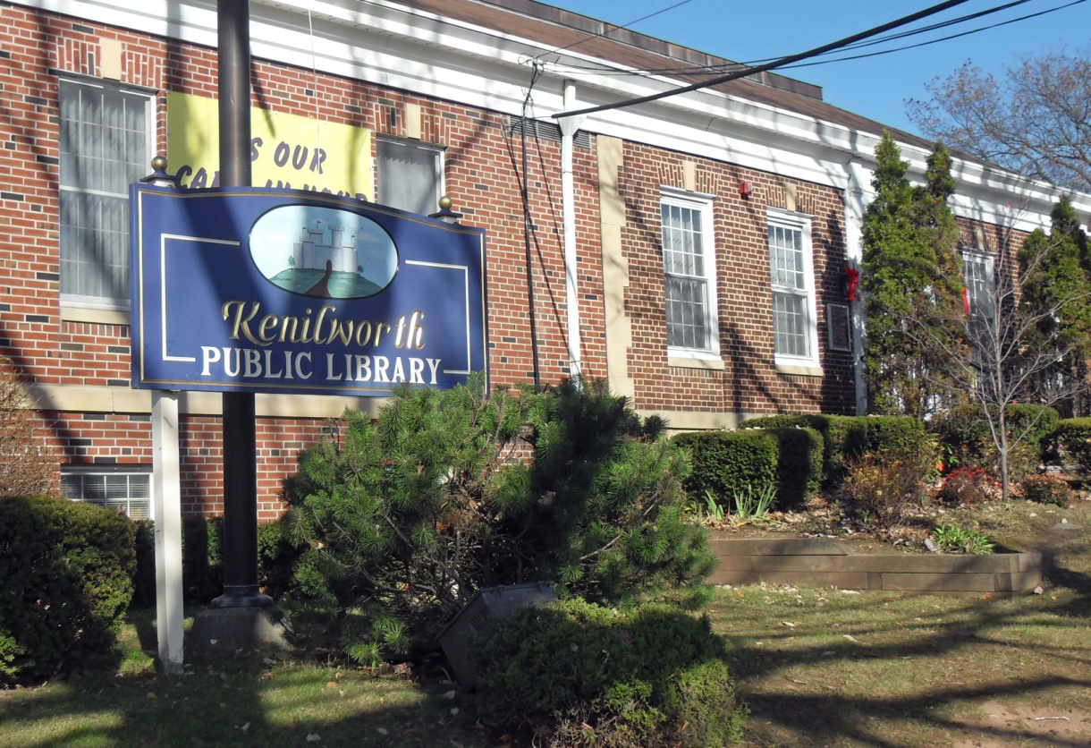

V. GOALS AND OBJECTIVES

The Municipal Land Use Law requires that all Master Plans contain a statement of principles, assumptions, policies and standards upon which the future development of the municipality are based. The Principles, Goals, Objectives and Development Policy of the Borough Master Plan satisfy this requirement and provide the foundation for the other components of the Master Plan.

A. RESIDENTIAL
- Protect residential neighborhoods from nonresidential encroachments.
- Preserve single family neighborhoods from any two family or multifamily encroachment.
- Permit sufficient residential opportunities, in locations with access to services, to help the Borough’s senior residents age in place.
- Allow opportunities for subsidized senior housing.
- Ensure that new residential development is consistent with and compatible to existing neighborhood character.
- Encourage the preservation and maintenance of all residential properties.
- Control the illegal conversion of single family homes into two family or multifamily buildings through code enforcement.

B. INDUSTRIAL
- Expand the allowed uses in the Industrial Zone to permit more economic activity and generate employment opportunities.
- Provide adequate infrastructure to meet the needs of industry.
- Encourage the redevelopment of Brownfields sites.
- Promote the growth of industrial uses by taking advantage of area transportation infrastructure.
- Promote Borough pride by upgrading the appearance of industrial areas.
- Protect air and water quality and the quality of life in the Borough by enforcing performance standards.

C. COMMERCIAL
- Retain existing commercial establishments by fostering a positive regulatory climate.
- Strengthen the appearance of commercial districts by adopting design and landscaping ordinances.
- Encourage the development of the Borough’s economic base by expanded the number of permitted uses to generate employment growth, increase property values and promote the improvement of underutilized properties.

D. THE BOULEVARD – DOWNTOWN
- Promote the economic vitality of the Downtown by adopting design and landscaping ordinances.
- Require that all visible facades of any building be aesthetically pleasing and meet property maintenance standards.
- Provide street furniture and streetscape elements to emphasize the Boulevard-Downtown as a safe and convenient place to work and shop.
- Adjust parking requirements along the Boulevard between 18th and 24th Streets to encourage new economic activity.
- Investigate the possibility of overnight parking for Boulevard residents in municipal lots.

E. INFRASTRUCTURE
- Continue to improve the Borough's infrastructure to better serve present and future residents and the business community.
- Maintain and improve the existing sanitary & storm sewer system.
- Encourage sensitivity to the existing watershed by being a better neighbor to our creeks and streams through cleanup efforts and discouraging homeowner encroachments.
- Encourage the New Jersey Turnpike Authority (NJTA) to improve Interchange 138 of the Garden State Parkway by enhancing stormwater drainage and improving visibility and geometry.
- Support the County of Union in their efforts to place the East Coast Bikeway within County Park property instead of along the Boulevard.

F. COMMUNITY
- Maintain & improve Kenilworth’s character & identity by promoting pride in the appearance of residential neighborhoods & commercial areas.
- Improve the aesthetic quality of the Borough's gateways through the use of innovative design for development projects & welcoming signage.
- Provide adequate public facilities for the Borough’s citizens, including schools, parks, library, open space, fire and police protection and solid waste disposal.
- Encourage the sharing of School District and Borough lands to provide adequate recreation opportunities for all. Investigate the possibility of establishing a joint recreation committee to oversee a joint recreation facility established by the Borough and School District.
- Preserve open space and protect natural, cultural and historic resources.
- Improve the development approval process by placing all zoning, subdivision and land use procedures under one comprehensive land development ordinance.
- Continue to seek ways to expand shared services with adjoining municipalities and the County of Union.
- Review the current street closing apparatus for dead ends to insure that they are safe and adequately marked.
- Improve Public Safety by working closely with the Police and Fire Departments and the Rescue Squad and promoting public support of them.
- Strive to enhance the quality of life for all of the Borough’s residents.
- Encourage the establishment of a new dedicated building to house the Community and Recreation Center.
- Encourage the establishment of a new dedicated building to house Public Safety Building to enhance public safety.
- Investigate the complete renovation of Borough Hall once a Public Safety Building is dedicated.

G. GREEN DEVELOPMENT
- Institute tree planting programs and preserve existing trees and landscaping to improve air quality and to preserve community character.
- Encourage sustainable development practices.
- Promote Best Management Practices to improve local stormwater drainage.
- Continue the Borough’s membership in Sustainable New Jersey and use their resources and programs to encourage sustainable development.
- Institute lot coverage regulations to minimize the amount of stormwater runoff.
- Preserve existing open spaces and protect them from development.
- Encourage energy efficient and renewable energy technologies as part of any new development.
- Create a strategy for the preservation or disposition of vacant Borough lands.
- Explore the use of renewable energy sources on Borough buildings and properties.

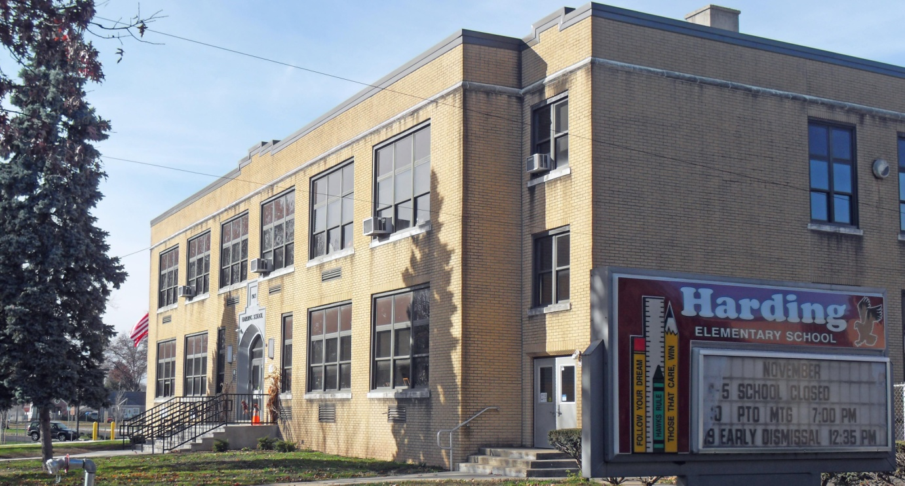

VI. EXISTING LAND USE AND ZONING

A. INTRODUCTION
The Land Use Element examines current development trends and sets a vision for future development throughout the Borough. This Plan establishes a development pattern for the Borough that considers characteristics such as existing land use patterns, environmental characteristics, compatibility with the planning efforts of adjacent municipalities and current and future land use demands.
This Land Use Element serves as a guide to achieve the goals and objectives established by the Borough’s Master Plan efforts.

B. EXISTING LAND USE
The land use Table below shows how land in Kenilworth is currently utilized as compared to previous calculations from 1996 and 1974.

TABLE 4 – LAND USE AREAS
USE TYPE | 2010 acres | 2010 % | 1996 acres | 1996 % | 1974 acres | 1974 %
Residential | 365 | 27% | 361 | 27% | 398 | 30%
Commercial | 83 | 6% | 59 | 4% | 50 | 4%
Industrial | 294 | 22% | 307 | 23% | 219 | 16%
Public | 71 | 5% | 78 | 6% | 64 | 5%
Transport Utilities | 25 | 2% | 25 | 2% | 15 | 1%
Open Space | 312 | 23% | 302 | 22% | 269 | 20%
Streets | 185 | 14% | 185 | 14% | 185 | 14%
Total developed | 1335 | 99% | 1317 | 98% | 1200 | 89%
Vacant | 9 | 1% | 27 | 2% | 144 | 10%
Total Area | 1344 | 100% | 1344 | 100% | 1344 | 100%
As shown in the table above, 27% of the Borough is dedicated to residential uses while 28% is dedicated to commercial and industrial uses. Vacant land equals 1%, reflecting a long term decline.

C. PLANNING BOARD RELIEF GRANTED 2001 - 2009
The Kenilworth Land Use Board, acting as a combined Planning Board and Zoning Board of Adjustment granted relief in 210 instances over the past nine years, averaging 23 approvals per year. The relief granted is summarized below.

RELIEF SOUGHT APPLICATIONS
COMMERCIAL PROPERTIES
Commercial site plans 54
Sign variance 5
Parking variance 4
RESIDENTIAL PROPERTIES
House enlargements into setbacks 68
Porch, deck or fence into setback 28
Subdivisions 24
Convert 1 family to 2 or more units 17
Shed or garage into setback 6
Swimming pool into setback 1
ZONING BOARD OTHER RELIEF
Interpretations of the Ordinance 2
Appeal of Zoning Officer decision 1

The above shows a significant number of house enlargements and intrusions into the setback area. The Planning Board believes that the recommendations of this Master Plan will help property owners by making more properties conforming in their zone and by using creative lot coverage Ordinances.

D. EXISTING ZONING DISTRICTS
The Borough currently has nine Zoning Districts. These are listed below:
- Residential 1 – R1
- Residential 2 – R2
- Residential 3 – R3
- Boulevard Gateway - BGD
- Local Commercial - LC
- Special Commercial - SC
- Commercial Industrial - CI
- Industrial - I
- Public Facility - PF
The above can be classified into four basic categories – residential, commercial, industrial and public. These categories are described below.

1. Residential Zones
The Borough has four Residential Zone Districts – the R-1, R-2, R-3 and the Boulevard Gateway (BGD) District.
The R-1 District is considered a low density zone allowing single family homes on a minimum of 6,000 Square Foot (SF) lots. The R-1 Residential Zone is confined to one area in the northern part of the Borough between Sheridan and Lafayette Avenues centered on North 19th Street.
The R-2 District is also considered low density with single family homes permitted on 5,000 SF lots. The R-2 is the primary residential zone in the Borough with most of the residentially zoned land within its boundaries throughout the community.
The R-3 District allows single family homes and two family homes on 5,000 SF lots. The R-3 has a much smaller area and has five widely scattered areas zoned as such.
The Boulevard Gateway District is a low density zone allowing single family homes on a minimum of 7,500 SF lots and requiring 75 feet of frontage along the Boulevard. The BGD is currently along the north side of the Boulevard between the Cranford border and North 8th Street.

2. Commercial Zones
The Borough has three commercial zones: the LC – Local Commercial; the SC – Special Commercial; and the CI – Commercial Industrial.
The LC Local Commercial District zone allows offices and retail sales in four zoned areas including: the Boulevard from 18th Street to Market Street; the intersection of North 14th Street and Monroe; and the intersections of Michigan Avenue and Fairfield Avenue and Michigan Avenue and Faitoute Avenue.
The Special Commercial district allows offices, retail, supermarkets, banks, funeral parlors, private schools, hotels and car washes. There is one area zoned S-C centered on the Boulevard between Market Street and South 31st Street.
The Commercial Industrial District allows offices, sales and retail, financial institutions, personal services and restaurants in six zoned areas. These are: Michigan and Lexington Avenues; South 31st Street and the Boulevard; Galloping Hill Road east of the Parkway; the Boulevard and North 26th Street; Route 22 and North Michigan Avenue; and, Monroe Avenue between North 8th and North 13th Streets.

3. Industrial Zone
The I – Industrial Zone allows offices, recreation, warehouses, research laboratories and manufacturing and industrial facilities in five areas of the Borough. These are: the Merck (formerly Schering) property east of the Parkway; Market Street and Passaic Avenue; the east side of Michigan Avenue near Jefferson and Federal Avenues; Lafayette Avenue west of North 15th Street; and the area north of Washington Avenue and west of North 14th Street.

4. Public Zone
The PF - Public Facility District allows public parks and recreational facilities, cemeteries, as well as public and parochial schools. There are six PF zoned areas in the Borough: the two cemeteries along Galloping Hill Road and the Boulevard; all of the lands of the County Park System including Galloping Hill Park and Black Brook Park; the Brearley School/Harding School property; and the Borough’s Di Mario Park.

E. ENVIRONMENTAL CHARACTERISTICS
The presence of environmental constraints must be considered when developing a Land Use Plan for a community. The location and types of environmental constraints help guide the type, intensity and location of development due to local, County and State requirements.
Due to its location, the Borough of Kenilworth contains a number of environmental features, including topography, glacial influences, subsurface geology, soils, steep slopes, wetlands, drainage and floodplains.
Union County and the Borough of Kenilworth lie entirely within the Piedmont Plains sub-province of northern New Jersey. This sub-province of New Jersey is an area of lowland with smooth, rounded hills separated by wide valleys sloping gently down to the Coastal Plain. The source for the following information is the 1996 Master Plan.

1. Topography
The topography of the Borough of Kenilworth can best be described as predominantly flat to gently sloping with some areas of rolling rounded hills. Elevations within the Borough vary predominantly from approximately elevation 60 to elevation 120. A maximum elevation of approximately 160 is located near the water tower west of Michigan Avenue and north of Via Vitale.

2. Glacial Influences
In New Jersey, three ice advances affected the surface composition. The last ice age, called the Wisconsin stage occurred about 10,000 years ago. Between ice advances, warmer periods occurred during which the glaciers retreated leaving behind deposits of various materials.
A 1967 Union County report of Physical Characteristics stated: "In Union County, the termination and retreat of the Wisconsin ice advance can be readily seen in the low, irregular hills of unsorted boulders, gravel, sand and fines, termed 'terminal moraine' or 'glacial marginal moraine'..."

3. Subsurface Geology
The geologic structure underlying the Borough - known as the Brunswick Formation - formed during the Triassic period approximately 225 million years ago. It consists of interblended deposits of soft red shale and sandstone laid down during a 10 million year long period.
This formation reaches thicknesses ranging up to 8,000 feet below the ground surface. Glacial deposits of gravel, sand and silt range to depths of several hundred feet over the Brunswick Formation. Throughout large areas of Kenilworth, a medium to coarse reddish brown sand overlays the Brunswick Formation of reddish brown shale. This sand layer is found at a depth of 5 feet to 8 feet below grade.

4. Soils
Six different generic soil types can be found within the Borough of Kenilworth. These are described below:
Recent alluvium - These soils are stratified deposits of silt and clay and are generally found near stream beds. Due to their heavy texture these soils offer very poor drainage.
Kame - These are soils deposited by glacial melt waters and streams forming narrow ridges. They are composed of assorted and homogeneous layers of variously sized sand and gravels. Drainage characteristics are good.
Ground moraine - This class consists of soils deposited by a glacier. Soil textures range from clays to boulders with silts predominating. Ground moraine deposits appear as flat to gently rolling on the surface. Poor surface and internal drainage characteristics are due to flat surfaces and heavy soil textures.
Marginal moraine - These soils were deposited at the front of the glacier. Soil textures range from clays to boulders with sand and silt predominating. Internal drainage characteristics are moderately good. Surface drainage conditions are fair to good.
Stratified drift - These soils consist of stratified deposits of silts and sandy silts deposited over debris left by a receding glacier. These soils usually exhibit good internal surface drainage.
Marsh - These are areas consisting of a layer of decomposed roots and organic material over a highly compressible layer of silt and clay deposits. High ground water conditions prevail during most of the year and drainage is poor.

The following table shows the amount of each of the above soils in the Borough.
TABLE 5 - SOILS
SOIL TYPE | ACRES | %AGE
Recent Alluvial | 99 | 7.4
Kame | 55 | 4.1
Ground Moraine | 414 | 30.8
Marginal Moraine | 569 | 42.3
Stratified Drift | 83 | 6.2
Marsh | 115 | 8.5
Water | 9 | .7
TOTAL | 1,344 | 100

As can be seen from the Table above the vast majority of soils within the Borough - approximately 73.1% - consist of glacial ground moraine or marginal moraine.

5. Steep Slopes
Steep slope is defined as the amount of vertical change in elevation (height) for every 100 feet of horizontal distance. A 5% slope is one which increases or decreases 5 feet vertically for every 100 feet of horizontal distance.
Slope analyses serve to indicate areas suitable for particular land uses. The following four slope ranges are generally used to categorize the slope characteristics of an area. They are described below with their best uses.
TABLE 6 - TYPES OF SLOPES AND USES
Slope | Description | Uses
Less than 2% | Nearly level | All industrial, commercial and residential uses
2 – 7% | Gently sloping | All residential and many types of industrial and commercial uses
8 – 15% | Moderately sloping | Low density residential, small industrial and commercial sites, multifamily units
15% and over | Steep slopes | Conservation and recreation

TABLE 7 - BOROUGH SLOPE AREAS
Slope % | Under 2% | 2 – 7% | 8 – 15% | 15% and over
Acreage | 936.9 | 358.4 | 36.8 | 11.9
% of land | 69.8% | 26.7% | 2.7% | .8%

6. Wetlands
Wetlands not only support aquatic life but serve to recharge underground aquifers. Strict State regulations regarding wetlands make development of these areas impossible or difficult. Due to the highly developed nature of Kenilworth, the extent of naturally occurring wetlands within the Borough is minimal. Wetlands extend along the Rahway River in close proximity to the banks. Some former wetland areas may have been filled many years ago before such activity was regulated. Wetlands also exist in the Northeast tip of the Borough on the Galloping Hill Golf Course along the banks of the West Branch of the Elizabeth River. Open water wetlands exist in Black Brook Park and along various brooks located in the Borough.

7. Drainage
Stormwater drainage patterns are governed by both natural and man-made features. Natural features which may affect drainage patterns in Kenilworth are the existing topography, rivers, brooks, ponds and subsurface soil conditions. Man-made features which may affect drainage patterns are underground piping systems and man-made ditches. Large highways may also affect drainage patterns by intercepting or blocking flow, thereby affecting drainage patterns on a large scale.
The Borough of Kenilworth has an extensive underground stormwater drainage system, in conjunction with surface inlets, to intercept and convey stormwater. Stormwater sewers are not combined with sanitary sewers.
The Borough of Kenilworth drains into three natural drainage areas by surface or subsurface conveyance. They are:

- Rahway River Basin – Most of the Borough’s lands drain to the Rahway River. Generally, all lands west of Michigan Avenue from Route 22 to the Garden State Parkway drain to the Rahway River. Most lands west of the Garden State Parkway from approximately Newark Avenue to the southern town boundary also drain to the Rahway River.

- Elizabeth River Basin - this is the second largest drainage area within the Borough. Galloping Hill Park and Golf Course and lands east and west of the Garden State Parkway south to approximately Newark Avenue drain to the West Branch of the Elizabeth River.

- Morses Creek Basin - the remaining portion of the Borough east of the Garden State Parkway between Newark Avenue and Colfax Avenue drains to Morses Creek drainage basin.

8. Floodplain
Flood hazard considerations are important to a community concerned with economic viability and the safety of its residents. Unregulated development in areas subject to flooding will generally create unsafe conditions for residents and result in property damage. Unregulated filling and encroaching of a flood prone area will reduce the capacity of the flood area to convey waters and will increase the size of the area subject to flooding, the depth of flooding and possibly the duration of flooding. The economic viability and desirability of the area is decreased by poor flood plain management.
The "Flood Boundary and Floodway Map - Community Panel No. 340-466-0001" which is a part of the Flood Insurance Study delineates engineering type parameters such as flood way, 100 year flood boundary and 500 year flood boundary.
The map shows the following flood hazard areas:
  - Near the westerly corporate limits along the drainage ditch which follows Lenape Park Dike and along tributaries Stream 10-30 and Branch 10-30-1. This also includes the area along the Black Brook to Shallcross Pond.
  - Near the northeast corporate limits with the golf course along the West Branch of the Elizabeth River. Only the 100 year flood boundary is shown.
  - Between Quinton Avenue and Bloomingdale Avenue west of the Parkway to the Borough’s boundary along Branch 10- 24.
  - Between Galloping Hill Road and Colfax Avenue east of the Parkway to the corporate limits. Various areas delineated along West Brook and Branch 10-24.
The current “Flood Insurance Rate Map” delineates the above mentioned areas.

VII. PROPOSED LAND USE ZONES

A. PROPOSED ZONING DISTRICTS
This Master Plan recommends that 12 Zoning Districts and three Overlay Zones be established. The proposed names are a more accurate description of the residential size and commercial activities of each particular zone.

  - R-6 Low Density Single Family Residential Zone District
  - R-5 Medium Density Single Family Residential Zone District
  - R-5A High Density One and Two Family Residential Zone District
  - BD Boulevard Downtown Zone District
  - AC Area Commercial Zone District
  - C Commercial Zone District
  - OR Office Research Zone District
  - I Industrial Zone District
  - G Government Zone District
  - P Park Zone District
  - CE Cemetery Zone District
  - CS Community Serving Zone District
  - SLO Senior Living Overlay Zone District
  - GO Gateway Overlay Zone District
  - Boulevard Downtown Residential Overlay
The proposed Zone Districts are described below.

B. RESIDENTIAL

1. R-6 Low Density Single Family Residential Zone District
The current R-1 Residential Low Density District should be renamed the R-6 Low Density Residential District to reflect the minimum lot size of 6,000 SF. This zone should continue to allow single family homes and public park land. Density should continue at 7.26 residential units per acre.
The existing R-1 zone should continue within the current boundaries of the proposed R-6 zone. In addition, properties along the North side of the Boulevard between 10th and 12th Streets as well as between Dorset Drive and North 7th Street should be included in the R-6 Zone.
2. R-5 Medium Density Single Family Residential Zone District
The current R-2 Residential Low Density District should be renamed the R-5 Residential Medium Density district to reflect the 5,000 SF minimum lot size in this zone. The zone should allow only single family homes and public park land. Density should continue at 8.71 residential units per acre.
The existing R-2 zone should continue within the existing boundaries of the zone.

3. R-5A High Density One and Two Family Residential Zone District
The current R-3 Medium Density Residential District should be renamed the R-5A High Density District to reflect the 5,000 SF minimum lot size and the higher density of this Zone. The zone should only allow one and two family homes and public park land. Density should be a maximum of 17.42 dwelling units per acre.
The currently zoned R-2 area in the vicinity of Washington Avenue, Cross Street and North 18th Street should be zoned R-5A. This reflects the existing land uses in the neighborhood and makes those properties conforming.

C. COMMERCIAL AREAS

1. BD - Boulevard Downtown Zone District.
This new district should extend along the first row of properties facing the Boulevard from 18th Street to Market Street. Allowed uses should include: sales and retail; offices; personal services; medical, dental and veterinary offices; banks and financial institutions; restaurants and bars; funeral homes; and private schools. .
The Board recognizes that mixed use developments that include a residential component can create vibrant environments that bring compatible land uses and public amenities together. This kind of development creates a pedestrian friendly environment which promotes public safety. This variety of uses enables people to live, work, play and shop in one place.
While residential uses have not been allowed on the Boulevard in quite some time, there is a pocket of preexisting nonconforming second floor apartments between 20th Street and 24th Street. Over twenty apartments exist in this area of the Boulevard. Rather than continue the nonconforming status of those properties, the Board believes it to be in the public interest to recognize the existing land use pattern and to bring as many properties as possible into conformity with the Land Use Ordinance. The Board recommends that this area, and only this area, be placed in the Residential Overlay zone with a minimum of two bedrooms per apartment.
The Borough would like to foster a consistent style look to the Boulevard - Downtown area. A design and pattern book should be prepared to show the preferred style to guide local merchants in this optional endeavor. Local merchants and civic groups will participate in the design selection. The design book will show styles of storefronts, street furniture, signage and other physical elements. The Borough will seek grant funding for the design book. Among the styles that may be considered are: Colonial; Georgian; Federal; and Victorian.
The Borough will encourage the placement of street furniture by property owners by allowing such furniture to be included in the landscaping requirement for the B-D District. A four foot wide sidewalk access shall be maintained around all street furniture. Parking standards in the BD District should be temporarily relaxed to encourage the revival of the Downtown area and to encourage business relocation to the Downtown. A relaxation of parking standards will allow more businesses to operate without having to apply for parking variances in addition to any other relief required. The six year Reexamination of the Master Plan, due in 2017, should look at this issue closely to see if any changes should be made based on development after this Master Plan is adopted.
The Board recommends that all properties in the BD District between 18th and 24th Streets, inclusive, shall provide one half of the required parking according to the Ordinance. This relaxation of requirements shall not apply to residential uses in the Residential Overlay zone. All other areas in the BD District shall provide the full amount of required parking due to the lack of street and area parking.
The Board further recommends the Planning Board and Borough Council revisit this issue during the next reexamination of the Master Plan or earlier should conditions warrant. This temporary adjustment is meant to be just that – a temporary measure to provoke and assist development along the Boulevard.

2. AC - Area Commercial Zone District
The proposed AC District will encompass the current SC District centered on the Boulevard between Market Street and South 31st Street. It will also encompass the lands in the C/I and I districts between the Garden State Parkway and the Rahway Valley Rail Line.
The Area Commercial District will allow: sales and retail; offices; personal services; medical, dental and veterinary offices; banks and financial institutions; restaurants and bars; funeral homes; private schools; supermarkets, hotels/motels; indoor health, racquet and sport facilities; car washes; automobile gasoline stations and automobile service stations.

3. C – Commercial Zone District
The proposed C District will take the place of the current C/I Commercial Industrial District and the LC – Local Commercial District and will be located in the following areas: the current LC zone at Michigan Avenue and Fairfield Avenue, the current C/I zone at Michigan Avenue between Fairfield Avenue and Lexington Avenue; the current C/I zone on Galloping Hill Road east of the Garden State parkway; the current L C zone at Michigan Avenue between Faitoute and Fairfield Avenues; the current C/I zone on the north side of the Boulevard east of North 26th Street; part of the current LC zone between the Boulevard and Newark Avenue; part of the current C/I zone north of Monroe Avenue between North 8 and North 13th Streets; the current LC zone centered on North 14th Street and Monroe Avenue; the current C/I zone on Route 22, and the part of the current I zone for properties facing Michigan Avenue between Route 22 and Black Brook Park.
The Commercial District will allow: sales and retail; offices; personal services; medical, dental and veterinary offices; banks and financial institutions; restaurants and bars; funeral homes; public utilities; and, private schools.
The Commercial District shall allow multifamily apartment buildings as a conditional use. Density shall be no more than 26 units per acre. Parking may be allowed in the required front yard if plantings and buffering are provided.

4. OR - Office Research Zone District
The proposed Office Research District will take the place of the current I Industrial District on lands owned by the Merck (Schering) campus east of the Garden State Parkway.
The OR District will allow: offices, warehouses, scientific or research laboratories; manufacturing; industrial facilities and public utilities.
Permitted Accessory Uses shall include: parking structures, cafeterias, helipads and day care centers primarily for use by employees.

5. I - Industrial Zone District
The proposed I Industrial District will include the remainder of the areas that are currently zoned Industrial plus the C/I zoned areas south of Monroe.
The I Industrial District will allow: offices; indoor recreational uses; warehouses; scientific or research laboratories; manufacturing; industrial facilities; public utilities; personal services; medical, dental and veterinary offices; banks and financial institutions; restaurants and bars; private schools; indoor health, racquet and sports facilities; and sales and retail.
The Borough should actively encourage the use of Industrial District properties as warehousing for Newark International Airport operations.
Permitted Conditional Uses shall include wireless telecommunications facilities and outdoor vehicle storage/parking.

D. NONCOMMERCIAL AREAS

1. G - Government Zone District
The proposed G - Government District will include all of the Government buildings and properties in the Borough, except for parks, which are in a different category. Examples of Government zoned parcels include; the Borough Hall complex; Public Schools; Public Works; Rescue Squad, Library; Fire Dept and Post Office.
The Borough should actively encourage and support the lighting of athletic fields on school property. The Borough should also encourage the placement of artificial turf on the heavily used school athletic fields.
The G - Government District will allow: public buildings or facilities used exclusively for public purposes by any branch of government.

2. P - Park Zone District
The proposed P - Park District shall allow all public parks within the confines of the Borough, such as: Lenape Park; Black Brook Park; Galloping Hill Park; and Di Mario Park.
The P - Park District will allow active or passive recreation and utilities.

3. CE - Cemetery Zone District
The CE - Cemetery District shall include all of the lands which are currently zoned PF and used as cemeteries.
The CE - Cemetery District shall only allow the internment of the dead.
4. CS - Community Serving Zone District
The proposed CS - Community Serving District shall include those lands currently occupied by uses that serve the community while owned by nongovernmental organizations, such as; churches; parochial schools; veteran’s organizations and other community groups.
The CS - Community Serving District shall only allow facilities used for recreational, social, educational and cultural purposes.

5. SLO - Senior Living Overlay Zone District
The current Industrial area between North 10th Street and North 12th Street between Washington and Monroe Avenues should be an overlay Senior Citizens Housing Zone. This would allow any age restricted (55+) housing as an overlay zone. A minimum of ten percent of the senior housing should meet affordable housing guidelines. All forms of senior living are encouraged. Density shall be no more than 36 units per acre and parking shall be provided in accordance with the Land Use ordinance. Recreational facilities shall be included as part of any senior complex and will include outdoor and indoor recreational areas.

6. GO - Gateway Overlay Zone District
The nonresidential zoned Gateway areas at the entrance to the Borough should be placed in an overlay Gateway Zone that will add enhanced landscaping requirements. The Gateway area shall include: North Michigan Avenue from Route 22 to Black Brook Park; Springfield Road from Route 22 to Black Brook Park; and, Kenilworth Boulevard starting at the Garden State Parkway and extending approximately 1,000 feet west to Market Street.
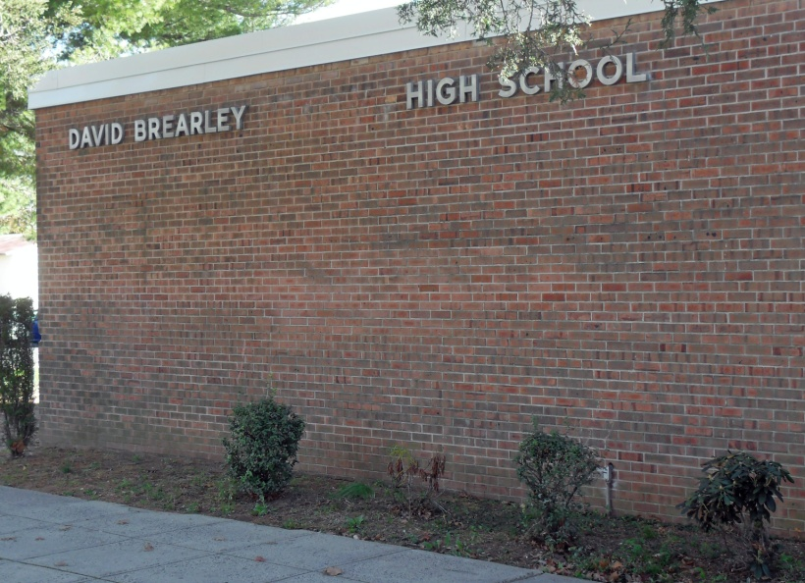
VIII. PROPOSED ZONING STRATEGIES

A. RESIDENTIAL ZONES

1. Floor Area Ratio
There is an increasing number of out of scale single-family residential homes throughout the Borough. There are a number of reasons for the creation of out of character residential single-family development, not the least of which is the Boroughs’ desirability as a place to live. Existing bulk standards and definitions have played a role in allowing the development of out of scale single-family housing.
Floor Area Ratio (FAR) is the sum of all the floors of a structure compared to the total area of the site. Use of a Floor Area Ratio calculation would be one of the tools that would limit the amount of volume of a proposed house.
To start the discussion on FAR, the Borough should consider a sliding scale between .5 and .66 FAR depending upon the size of the property, and which would allow for the construction of homes deemed desirable without overwhelming the existing character of the neighborhood.
The Borough should consider implementation of a floor area ratio standard for residential uses.

2. Building and Lot Coverage
Another tool useful in controlling how to scale single-family residential development is a building coverage and lot coverage standard. A building coverage standard would limit the amount of land buildings could occupy on a particular site. A lot coverage standard would limit the amount of impervious coverage on a particular site and would regulate the percentage of a lot that may be covered by material that prevents the absorption of storm water into the ground. Any pervious surface cover should be calculated at the appropriate ratio.
Impervious cover, building cover and lot cover should all be clearly defined in the Ordinance.
The Borough should consider an impervious cover limit of between 50% and 60%, depending upon the size of the lot. The Borough should also consider a building coverage limit of 40% to 50%.
Building and lot coverage standards can reduce flash flooding by providing additional surface area for ground water absorption. The Borough should consider implementation of a building and lot coverage standard for residential uses.

3. Building Setbacks
New buildings on corner lots should have two front yard setbacks with appropriate front yard setback distances to each street.
New building side yard setbacks in the R-6 Zone should have at least 20% combined side yard setbacks and R-5 and R-5A Zones should have a minimum 15% combined sideyard setback.
Front porches may be allowed to violate the front yard setback provided that: they are open; they shall not extend any further than six feet into the required setback; they shall only front a living area of the home; and they shall also not encroach more than one third of the way into the required front yard setback, excluding steps.

4. Front Yard Setback
Residential front yard setback shall not be encroached upon except by an open porch and a driveway which shall take up no more than 25% of the lot frontage.

5. Residential Cantilevers
Continue the current practice of allowing a two foot second floor cantilever in the front yard of a residential structure.

6. Multigenerational Family Accommodations
The current Multigenerational Family Accommodations definition shall be replaced with one for senior suites which shall permit seniors aged 62 and older to live in accessory apartments in a single family residential unit.

7. Certificate of Occupancy for Residences
A Certificate of Occupancy inspection shall be conducted when residential property changes ownership to ensure compliance with applicable construction and zoning codes.

8. New Two Family Homes
All new two family homes shall require larger lot sizes of 7,500 SF with a maximum density of 11.6 units per acre.

B. COMMERCIAL ZONES

1. Signage
Signage is considered one of the most important amenities desired by the business community, yet is extremely difficult to regulate. The numerous elements of a sign: size; illumination; lettering; color; and orientation all present difficulties while demand for signage increases steadily.
The Borough recognizes that signage is particularly important to the success of a business as well as crucial to the beauty and enjoyment of the Downtown and other commercial areas.
The Board should consider a new Sign Ordinance that considers: number of signs permitted; area of signs; height of signs; setback from right of way; and illumination and type of sign. This reconsideration of the Sign Ordinance is very important given that the Borough’s signage standards have not been reviewed for at least 15 years.

2. Landscaping/Buffer
Add requirements for landscaping and buffer between residential and nonresidential uses and add requirements for additional landscaping by commercial applications.

3. Outdoor Restaurant Seating
Allow outdoor restaurant seating as an allowed accessory use to a permitted restaurant provided that such eating establishment provides a minimum five foot clearance walkway on any established sidewalk for the protection of pedestrians.

C. APPLICABLE TO ALL ZONES

1. Green Technologies
Allow solar panels and wind energy projects throughout the Borough with appropriate safeguards for impacts to residential properties.
2. Definitions
Expand the definitions section of the Land Use Ordinance to fully explain terms to guide the Board and staff in interpreting applications for development.

3. Street Widening
Should any street within the jurisdiction of the Borough need to be widened, then any and all utility poles shall be moved by the appropriate utility companies to accommodate that widening.

4. Storm Water Management
Require the use of rain gardens, dry wells and other measures to reduce the amount of storm water runoff entering the streets and storm sewers from properties that exceed building cover and impervious cover limits and encourage stormwater management measures for any project that adds 400 SF or more of impervious cover.
A Certificate of Occupancy inspection at the time of ownership changes shall insure that sump pumps are not tied in the sanitary sewer system.
Redefine impervious cover to meet NJ State Department of Environmental (NJ DEP) protection standards that define gravel surfaces, pools and decks as impervious cover.
Use NJ DEP stormwater standards for major and minor development. Create Borough standards for small developments that do not require NJ DEP regulation. Small development shall also include limitations on the amount of fill allowed before triggering an approval.

5. Parking Standards
Update all parking requirements with contemporary standards.

6. Zoning Ordinance
A new Zoning Ordinance shall be prepared which better protects the Borough from unwanted and illegal development and gives homeowners a clear understanding of what they can and cannot do with their property.
Major and minor site plans shall be clearly defined in the Ordinance. Minor site plans shall continue to require Land Use Board approval with no public notice necessary. Administrative Site Plan waivers for minor changes to commercial sites may be granted under very limited circumstances by a newly created Administrative Site Plan Waiver Subcommittee of the Planning Board.
Fines shall be raised for Land Use Ordinance violations as well as Property Maintenance violations. The Property Maintenance Code shall be updated with nonresidential area standards.

7. Recycling
Encourage recycling in public places by providing appropriate containers.

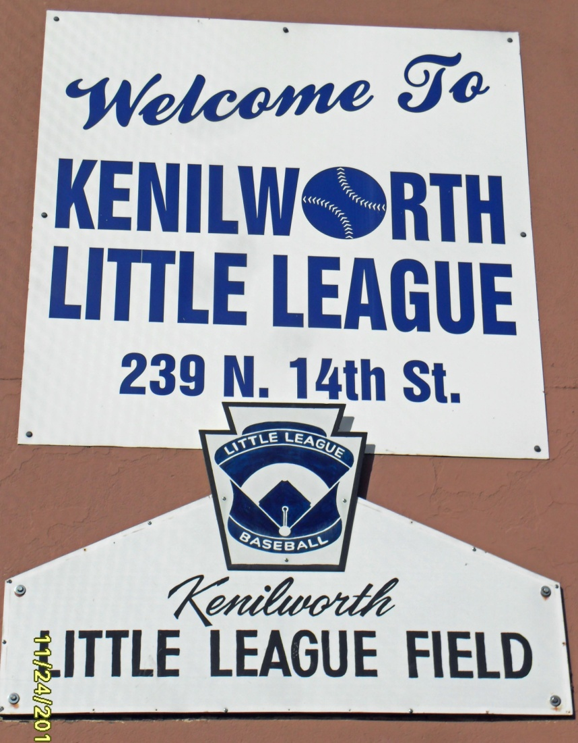

HOUSING ELEMENT OF THE MASTER PLAN

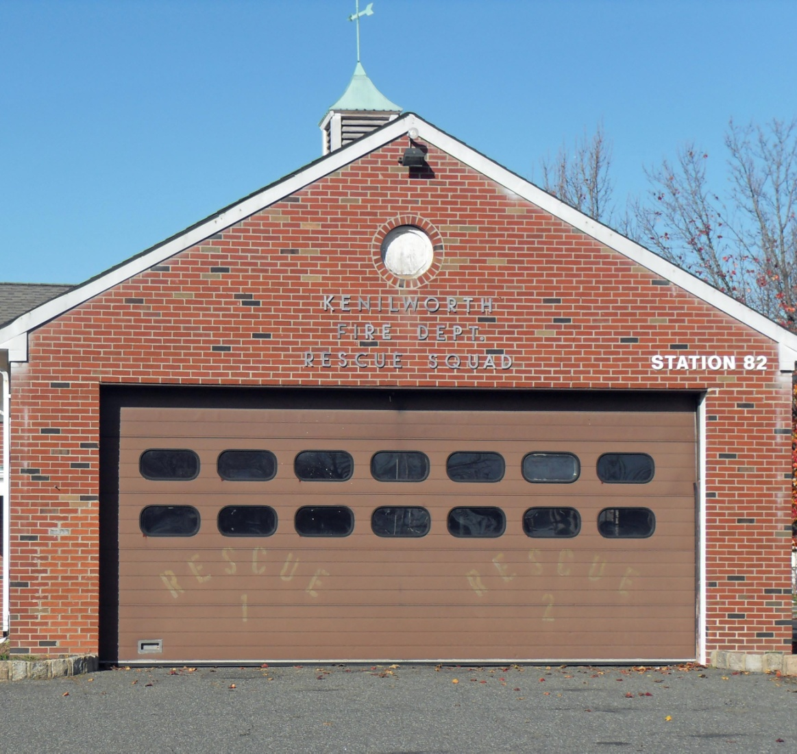

I. INTRODUCTION TO THE HOUSING ELEMENT

With the passage of the Fair Housing Act in 1985 (P.L. 1985, C.222), the Municipal Land Use Law (MLUL) was amended to require a Housing Element as a mandatory element of the municipal Master Plan. A variety of components must be incorporated into every Housing Element, summarized as follows:
- An inventory of the municipality's housing stock by age, condition, value and occupancy characteristics;
• A projection of future housing construction for the next six years;
• An analysis of the municipality's demographic characteristics including household size, income level and age;
• An analysis of existing and future probable employment characteristics of the municipality;
• A determination of the municipality's present and prospective fair share of low and moderate income housing and its capacity to accommodate low and moderate income housing; and
• A consideration of the lands that are most appropriate for the construction of low and moderate income housing, including structures which may be rehabilitated and lands of developers, if any, who have expressed a commitment to provide low and moderate income housing.
These components will be addressed in the course of this Master Plan, as explained below.

II. ORGANIZATION OF THIS ELEMENT

The intention of this Element of the Master Plan is to address the statutory requirements of the Municipal Land Use Law as noted above.
The initial part of this Element, titled Section 3, will list the Housing Objectives of the Borough. The following section (Section 4) will address the MLUL components cited above. An overview of the Borough’s affordable housing status will follow in Section 5.

III. HOUSING OBJECTIVES

Each Element of the Master Plan contains a section concerning the goals and objectives of that specific element. The goals and objectives of this Housing Element and Growth Share Plan are as follows:

        - Although there is limited available land capacity where higher density inclusionary housing could be encouraged in the Borough, appropriate residential development should be inclusionary and provide for its share of affordable housing as directed by NJ state statute.

- The Borough shall allow senior suites in private residences and shall maintain the appropriate records to document these types of residences.

- The Borough shall research opportunities for the rehabilitation of homes which are in need of repair and which are occupied by low and moderate income households.

- The Borough shall encourage the establishment of an additional Group Home for the Developmentally Disabled. This provides vital assistance to a sector of the population in need and fulfills current state affordable housing goals.

- The Borough shall encourage senior citizen age restricted housing to offer our older residents a place to live near home when they no longer need a full size house with all of its attendant maintenance responsibilities. A Senior Living Overlay Zone shall be established which will allow age restricted housing.

- The Borough will encourage the establishment of subsidized senior housing for adults 62 and over at an appropriate location in the Borough.

IV. MUNICIPAL LAND USE LAW REQUIRED COMPONENTS (NJSA 40:55D-28.3)

A. An inventory of the municipality's housing stock by age, condition, value and occupancy characteristics.

The 2000 US Census is our primary source for the housing information required by the statute. While the 2010 Census data is expected to be substantially similar to the enclosed information, it is the intention of the Planning Board to update this Master Plan with Census generated data when it is available later in 2011.
The Census Bureau found 2,926 total housing units in the Borough in 2000.
The age of The Borough of Kenilworth’s housing stock is somewhat older than one might expect at a first glance at the Borough. At the time of the 2000 US Census 87.1% of all housing stock was over 40 years old and constructed before 1970. This demonstrates Kenilworth’s maturity as a suburb.
TABLE 1 - HOUSING STOCK AGE
YEAR STRUCTURE BUILT | Number | %
1999 – March 2000 | 30 | 1
1995 – 1998 | 42 | 1.4
1990 – 1994 | 30 | 1
1980 – 1989 | 73 | 2.5
1970 – 1979 | 202 | 16.9
1960 – 1969 | 321 | 11
1940 – 1959 | 1718 | 58.7
1939 or earlier | 510 | 17.4
US CENSUS
The condition of the Borough of Kenilworth’s housing stock is good. The Census Bureau reports that there are no homes in the Borough without complete plumbing facilities, kitchen facilities or without telephone service. The Borough Code Enforcement Officer has responded diligently to complaints concerning property maintenance and code violations and has yet to find any home that is not in good condition.
The value of the Borough of Kenilworth’s housing stock was fairly high for the area in the 2000 census numbers, as shown below. Housing values rose considerably due to the rapid increase in housing values following the 2000 stock market crash through 2008. The Great Recession of 2008 and current market conditions have significantly impacted housing prices, causing a retreat in values from the 2008 peak. Today’s values are conservatively estimated to be between 75% and 100% of the 2000 values, anecdotally reported by local realtors.

TABLE 2 - HOUSING VALUE
VALUE | Number | %
Less than $50,000 | 7 | 0.3
$50,000 to 99,999 | 16 | 0.8
$100,000 to 149,999 | 360 | 17.4
$150,000 to 199,999 | 1,083 | 52.3
$200,000 to 299,999 | 568 | 27.4
$300,000 to 499,999 | 37 | 1.8
$500,000 to 999,999 | 0 | 0
$1,000,000 or more | 0 | 0
Median value in dollars | $175,900
US CENSUS

The occupancy characteristics reported by the Census Bureau are shown below.

TABLE 3 - HOUSING UNITS PER STRUCTURE
UNITS IN STRUCTURE | Number | %age
1 unit, detached | 2,260 | 77.2
1 unit, attached | 35 | 1.2
2 units | 539 | 18.4
3 or 4 units | 74 | 2.5
5 to 9 units | 6 | 0.2
10 to 19 units | 0 | 0
20 or more units | 3 | 0.1
Mobile home | 9 | 0.3
Boat, RV, van, etc. | 0 | 0
US CENSUS
TALE 4 - ROOMS PER STRUCTURE

ROOMS | Number | %age
1 room | 6 | 0.2
2 rooms | 18 | 0.6
3 rooms | 96 | 3.3
4 rooms | 321 | 11
5 rooms | 630 | 21.5
6 rooms | 788 | 26.9
7 rooms | 612 | 20.9
8 rooms | 304 | 10.4
9 or more rooms | 151 | 5.2
Median rooms | 6

US CENSUS

TABLE 5 - OCCUPANTS PER ROOM
OCCUPANTS PER ROOM | Number | %age
Total occupied housing units | 2,854 | 100
1.0 or less | 2826 | 99
1.01 to 1.50 | 9 | 0.3
1.51 or more | 19 | 0.7
US CENSUS

TABLE 6 - HOUSEHOLD AND FAMILY SIZES
HOUSEHOLDS BY TYPE | Number | %age
Total Households | 2854 | 100
Family households | 2117 | 74.2
With own children under 18 years | 816 | 28.6
Married couple family | 1666 | 58.4
With own children under 18 years | 692 | 24.2
Female householder, no husband | 340 | 11.9
With own children under 18 years | 102 | 3.6
Nonfamily households | 737 | 25.8
Householder living alone | 611 | 21.4
Householder 65 or older | 313 | 11
Households with under 18 years old | 908 | 31.8
Households with 65 years or older | 1009 | 35.4
Average household size | 2.69
Average family size | 3.15
US CENSUS

TABLE 7 - NUMBER IN HOUSEHOLD
HOUSING TENURE | Number | %age
Occupied housing units | 2854 | 100
Owner occupied | 2229 | 78.1
Renter occupied | 625 | 21.9
Average household of owner occupied unit | 2.73
Average household of renter occupied unit | 2.55
US Census

TERMS USED (US Census Bureau)

Family
A group of two or more people who reside together and who are related by birth, marriage, or adoption is considered a family.
Family household
A family includes a householder and one or more people living in the same household who are related to the householder by birth, marriage, or adoption. All people in a household who are related to the householder are regarded as members of his or her family. A family household may contain people not related to the householder, but those people are not included as part of the householder's family in census tabulations. Thus, the number of family households is equal to the number of families, but family households may include more members than do families. A household can contain only one family for purposes of census tabulations. Not all households contain families since a household may comprise a group of unrelated people or one person living alone.
Household
A household includes all the people who occupy a housing unit as their usual place of residence.
Household size
The total number of people living in a housing unit is referred to as household size.

B. A projection of future housing construction for the next six years.

Very little vacant land is currently available in the Borough. Future residential growth may be infill, or replacement housing, or a possible influx of housing in commercial areas.
When reviewing the number of housing units certified and demolitions performed between 2000 and 2009, 42 housing units were added to the Kenilworth housing inventory in that 10 year period. This averages to 4 homes per year.
Based upon the past 10 years as well as proposed zoning changes, the Borough of Kenilworth projects that 24 additional housing units may be added to the Borough’s inventory between 2011 and 2016. This is based on four units per year over six years.

TABLE 8 - RESIDENTIAL HOUSING GROWTH 2000 - 2009
YEAR | CERTIFICATES OF OCCUPANCY | DEMOLITIONS | NET HOUSING
2000 | 10 | 2 | 8
2001 | 2 | 0 | 2
2002 | 3 | 4 | -1
2003 | 9 | 13 | -4
2004 | 17 | 9 | 8
2005 | 15 | 6 | 9
2006 | 16 | 5 | 11
2007 | 10 | 6 | 4
2008 | 5 | 3 | 2
2009 | 6 | 3 | 3
TOTALS | 93 | 51 | 42
NJ Department of Community Affairs – Construction Reporter

The Table below shows Commercial growth in the Borough over the past ten years. While this growth has been fairly substantial, much of it has occurred on the Merck campus.

COMMERCIAL GROWTH 1996 - 2007

TABLKE 9 - CERTIFICATES OF OCCUPANCY ISSUED BY SQUARE FOOTAGE
Year | B-Office | M-Retail | A-1 | A-2 | A-3 | Multi | Indust | Storage
2000 | 6048 | 0 | 0 | 0 | 0 | 0 | 10150 | 218070
2001 | 157774 | 0 | 0 | 0 | 0 | 0 | 0 | 0
2002 | 135302 | 0 | 0 | 0 | 0 | 0 | 70724 | 7200
2003 | 0 | 362368 | 0 | 0 | 1830 | 0 | 0 | 0
2004 | 0 | 0 | 0 | 0 | 0 | 0 | 0 | 0
2005 | 0 | 0 | 0 | 0 | 0 | 0 | 47400 | 0
2006 | 0 | 0 | 0 | 0 | 0 | 0 | 0 | 0
2007 | 16582 | 0 | 0 | 0 | 0 | 0 | 0 | 0
2008 | 0 | 0 | 0 | 0 | 0 | 0 | 0 | 0
2009 | 0 | 0 | 0 | 0 | 0 | 0 | 0 | 0
TOTAL | 315706 | 362368 | 0 | 0 | 1830 | 0 | 128274 | 225270
NJ Dept of Community Affairs – Construction Reporter

Explanation of Categories
B Office buildings
M Mercantile uses
F Factories (indust)
S Storage uses
A-1 Concert halls, TV studios, entertainment venues
A-2 Night clubs, restaurants, taverns
A-3 galleries, bowling alleys, funeral parlors, gymnasiums
Multi Multi family such as hotels and motels

TABLE 10 - DEMOLITION PERMITS ISSUED FOR NONRESIDENTIAL USES
Year | B-Office | M-Retail | A-1 | A-2 | A-3 | Multi | Indust | Storage
2000 | 4 | 0 | 0 | 0 | 0 | 0 | 0 | 0
2001 | 0 | 0 | 0 | 0 | 0 | 0 | 0 | 0
2002 | 0 | 0 | 0 | 0 | 0 | 0 | 0 | 0
2003 | 2 | 0 | 0 | 0 | 0 | 0 | 0 | 0
2004 | 3 | 0 | 0 | 0 | 0 | 0 | 0 | 0
2005 | 2 | 0 | 0 | 0 | 0 | 0 | 0 | 0
2006 | 0 | 0 | 0 | 0 | 0 | 0 | 0 | 0
2007 | 1 | 0 | 0 | 0 | 0 | 0 | 0 | 0
2008 | 1 | 0 | 0 | 0 | 0 | 0 | 0 | 0
2009 | 0 | 0 | 0 | 0 | 0 | 0 | 0 | 0
TOTAL | 13 | 0 | 0 | 0 | 0 | 0 | 0 | 0
NJ Dept of Community Affairs – Construction Reporter

The number of total nonresidential demolition permits issued was low with only 13 permits issued between 2000 and 2009 and all were for office space. Presuming a 1,000 SF average per demolished office, a total of 13,000 SF of office space would be deducted from the 315,706 SF of new office space constructed, for a net total of 302,706 SF of office.
Based upon the past ten years of growth, future commercial growth seems to be certain. However, given that the economy is still in the Great Recession with no definite recovery in sight, any growth seems to be contingent upon an economic recovery that may be fragile at best.

C. An analysis of the municipality's demographic characteristics including household size, income level and age.
This data is also taken from the 2000 US Census Bureau figures.
The Census Bureau statistics show a solid middle class community with an average household size of 2.69 people and with an average family size of 3.17 people. Median household income was $59,929 with 58.5% of households reporting $50,000 annual income or more. Although the population remained stable between 2000 and 2009, gaining 66 people, the number of people below 18 years old was 1,596 or 20.8% of the population. The number of people over 65 years of age was 1,339 people or 18.2% of the overall population.

TABLE 11 - AVERAGE SIZE
Average household size | 2.69
Average family size | 3.15
US Census

TABLE 12 - HOUSEHOLD INCOME IN 1999
 | Number | %age
HOUSEHOLDS | 2,846 | 100
Less than $10,000 | 74 | 2.6
$10,000 to 14,999 | 129 | 4.5
$15,000 to 24,999 | 271 | 9.5
$25,000 to 34,999 | 310 | 10.9
$35,000 to 49,999 | 396 | 13.9
$50,000 to 74,999 | 718 | 25.2
$75,000 to 99,999 | 503 | 17.7
$100,000 to 149,999 | 317 | 11.1
$150,000 to 199,999 | 77 | 2.7
$200,000 or more | 51 | 1.8
Median household income | $59,929
US Census

TABLE 13 - FAMILY INCOME IN 1999
 | Number | %age
FAMILIES | 2,114 | 100
Less than $10,000 | 32 | 1.5
$10,000 to 14,999 | 15 | 0.7
$15,000 to 24,999 | 148 | 7
$25,000 to 34,999 | 185 | 8.8
$35,000 to 49,999 | 284 | 13.4
$50,000 to 74,999 | 599 | 28.3
$75,000 to 99,999 | 460 | 21.8
$100,000 to 149,999 | 304 | 14.4
$150,000 to 199,999 | 46 | 2.2
$200,000 or more | 41 | 1.9
Median family income | $66,500
Per Capita income | $24,343
Median earnings
Male, full time, year round worker | $40,808
Female, full time, year round worker | $34,698
US Census

TABLE 14 | Number | %
TOTAL POPULATION | 7,675 | 100
Male | 3,723 | 48.5
Female | 3,952 | 21.5
Under 5 years | 423 | 5.5
5 to 9 years | 467 | 6.1
10 to 14 years | 446 | 5.8
15 to 19 years | 391 | 5.1
20 to 24 years | 400 | 5.2
25 to 34 years | 1,089 | 14.2
35 to 44 years | 1,273 | 16.6
45 to 54 years | 1,077 | 14
55 to 59 years | 384 | 5
60 to 64 years | 326 | 4.2
65 to 74 years | 662 | 8.6
75 to 84 years | 593 | 7.7
85 years and over | 144 | 1.9
Median age | 39.7
18 years and over | 6,079 | 79.2
Male | 2,891 | 37.7
Female | 3,188 | 41.5
21 years and over | 5,864 | 76.4
62 years and older | 1,578 | 20.6
65 years and over | 1,399 | 18.2
Male | 567 | 7.4
Female | 832 | 10.8

D. An analysis of existing and future probable employment characteristics of the municipality.

TABLE 15 - EMPLOYMENT STATUS

EMPLOYMENT STATUS | Number | %
Population 16 years and older | 6,203 | 100
In labor force | 3,992 | 64.4
Civilian labor force | 3,992 | 64.4
Employed | 3,810 | 61.4
Unemployed | 182 | 2.9
Armed Forces | 0 | 0
Not in labor force | 2,211 | 35.6

US Census

TABLE 16 - POPULATION ESTIMATES
YEAR | POPULATION
2000 | 7,679
2001 | 7,694
2002 | 7,691
2003 | 7,658
2004 | 7,640
2005 | 7,602
2006 | 7,580
2007 | 7,572
2008 | 7,596
2009 | 7,663
NJ Department of Labor
TABLE 17 - TOTAL LABOR FORCE, EMPLOYED, UNEMPLOYED AND UNEMPLOYMENT RATE
YEAR | LABOR FORCE | EMPLOYED | UNEMPLOYED | UNEMPLOYMENT RATE
2000 | 4,122 | 3,988 | 133 | 3.2
2001 | 4,127 | 3,967 | 160 | 3.9
2002 | 4,182 | 3,958 | 223 | 5.3
2003 | 4,176 | 3,954 | 222 | 5.3
2004 | 4,151 | 3,966 | 185 | 4.5
2005 | 4,096 | 3,908 | 188 | 4.6
2006 | 4,144 | 3,947 | 198 | 4.8
2007 | 4,130 | 3,948 | 182 | 4.4
2008 | 4,177 | 3,940 | 238 | 5.7
2009 | 4,206 | 3,798 | 408 | 9.7
NJ Dept of Labor

The above job statistics reflect national and state trends resulting from the Great Recession and the attendant rise in unemployment. The figures for 2009 show an unemployment rate marginally higher than the NJ and US rates. The rates above also fail to show the number of workers whose unemployment benefits have expired and are no longer seeking work.
Given the current economic climate it seems reasonable to assume that there will be no job growth for the foreseeable future, with any future job growth seeming rather anemic compared the past expansions.

E. A determination of the municipality's present and prospective fair share of low and moderate income housing and its capacity to accommodate low and moderate income housing.

The Borough has a reasonable share of affordable housing and expects that future housing growth will occur in two areas. First is the proposed Senior Living Overlay Zone between North 10th and 12th Streets which will only allow age restricted housing with a percentage set aside as affordable. Second is infill and replacement housing in the residential zone districts.

F. A consideration of the lands that are most appropriate for the construction of low and moderate income housing, including structures which may be rehabilitated and lands of developers, if any, who have expressed a commitment to provide low and moderate income housing.

Several specific zoning changes are envisioned at this time as outlined in #E above. A Senior Living Overlay Zone is proposed between North 10th and 12th Streets. Any senior housing built will include affordable units.
The Borough will also investigate the possibility of placing an additional Group Home for the Developmentally Disabled in town to provide additional affordable housing units. This would accommodate a portion of the population in need of housing as well as address the need of local residents.

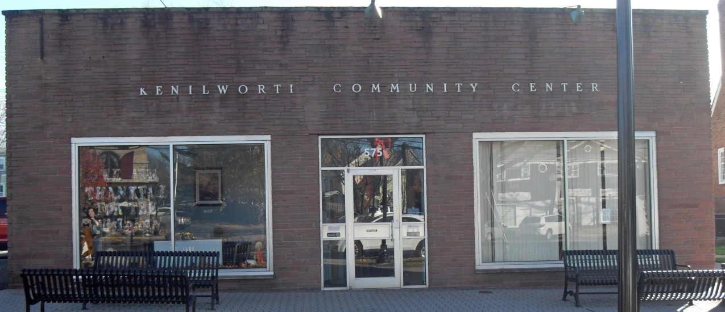

V. CONCLUSION

The Borough’s Housing Element projects little future single family residential growth in the foreseeable future.
The Borough anticipates that affordable housing units will be generated by the proposed Senior Living Overlay zone. The Borough also will look into the possibility of establishing an additional group home for the Developmentally Disabled which by its very nature would constitute affordable housing.

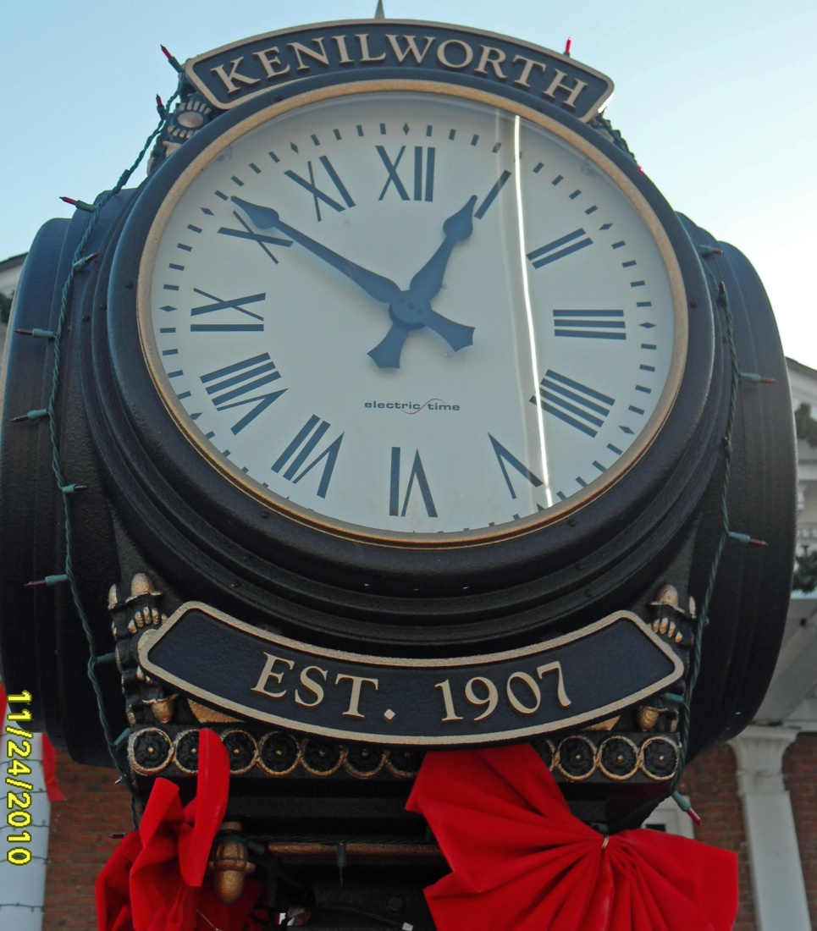

STATEMENT OF PLAN RELATIONSHIPS

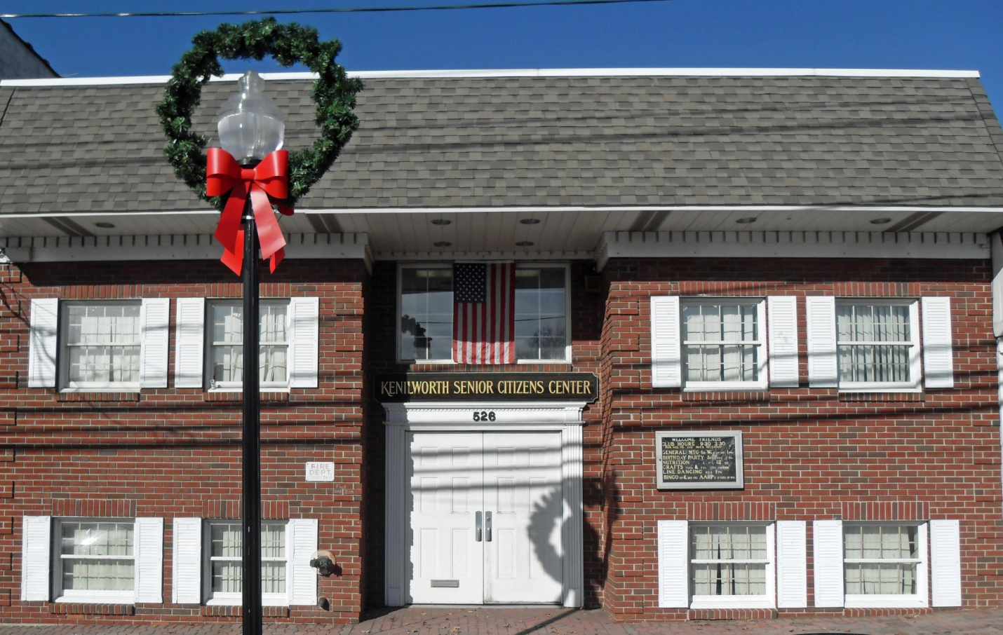

I. INTRODUCTION

The New Jersey Municipal Land Use Law (MLUL) requires that the Borough state the relationship of its Master Plan to the plans of adjacent communities, the Union County Master Plan, the State Development and Redevelopment Plan (SDRP), and the District Solid Waste Management Plan.
The policy of the Borough of Kenilworth is to work with neighboring municipalities, the County, and the State, in order to advance sound planning and develop compatible plans.
This section of the Borough Master Plan analyzes the relationship of the Borough plan to the plans of the State, the County, and adjoining municipalities.

II. ANALYSIS OF SURROUNDING COMMUNITIES
The Borough of Kenilworth is bordered by Union Township to the north and east, Roselle Park Borough to the south, Cranford Township to the south and Springfield Township to the west.

A. Union Township
Bordering Kenilworth to the north and east, Union Township adjoins well over half of the Borough. Along the northern border Union public lands adjoin Borough parkland. Industrial lands adjoin the Borough’s Industrial and Commercial zones. Further east, Galloping Hill Park straddles the Union/Kenilworth border. Along the eastern boundary, retail business and both one family and senior citizen residential zones adjoin the Borough’s Office Research and Industrial zones. With the exception of the industrial zone adjoining Union residential zoning, the districts are compatible with each other.

B. Roselle Park Borough
Kenilworth shares its southern border along Colfax Avenue and Sumner Avenue with Roselle Park Borough. Kenilworth zoning in this area calls for residential uses and industrial uses. Roselle Park zones the adjoining lands as R-1 and R-4. Both are Residential zones. The R-1 zone south of Colfax Avenue allows single family residential homes. The R-4 Garden Apartment District south of Sumner Avenue adjoins the Borough’s Industrial zone. The Garden Apartment zone provides a transition use from the Industrial zone in Kenilworth. The residential districts along Colfax Avenue are consistent with one another.

C. Cranford Township
Kenilworth shares a land boundary with Cranford to the south and west. R-1 and R-3 one family residential districts abut Borough zoned residential land. The Orange Avenue School and the Cranford Pool adjoin Kenilworth residential zones. Along the western boundary of Kenilworth and Cranford is Nomahegan Park. Kenilworth has zoned all county open space as Park. These zone districts are consistent with each other.

D. Springfield Township
Directly abutting Kenilworth to the west is Springfield Township. The portion of Springfield bordering Kenilworth consists of lands planned for public open space associated with Lenape Park, the Rahway River, and Nomahegan Brook. These areas are zoned OS-GU for Open Space –Government Use which allows public parks and open space. The land use plans along the Springfield and Kenilworth common border are consistent.

III. UNION COUNTY PLAN

In 1998 Union County prepared a Master Plan consisting of the following elements:
- Goals and Objectives
- Demographics
- Land Use Plan
- Circulation/Transportation Plan
- Economic Development Plan
Primary plan goals are as follows:
A. Housing
Goal: Promote the provision of a broad range of housing opportunities for all income levels and household types by encouraging the maintenance or rehabilitation of the existing housing stock and through the construction of new housing units.

B. Development
Goal: To facilitate the development of Union County by directing new growth to environmentally suitable areas that can be provided with essential infrastructure and support facilities and to revitalize the urban centers and corridors within the County.

C. Transportation/Circulation
Goal: To promote the development of an improved and balanced multi-modal transportation system that integrates and links highway, bus, rail, air, waterborne transport systems and pedestrian and bicycle facilities.

D. Economic Development
Goal: Continue County sponsored economic development efforts to reduce unemployment, provide year-round employment opportunities and enhance the tax base by encouraging compatible industrial, commercial, office and retail facilities to locate or expand in Union County.

E. Conclusion
Planning goals in Kenilworth are consistent with goals identified in the Union County Master Plan.

IV. SOLID WASTE MANAGEMENT PLAN
The New Jersey Solid Waste Management Act (N.J.S.A. 13:1E-1 et seq.) established a comprehensive system for the management of solid waste in New Jersey. The act designated all of the state's counties and the Hackensack Meadowlands District as solid waste management districts. On August 13, 1980, the Department of Environmental Protection (DEP) approved the Union County District Solid Waste Management Plan. DEP passed the most recent amendment to this Plan on April 27, 2006.
Kenilworth complies with all state refuse and recycling requirements and will continue to work with the County to achieve the planning goals enumerated in the Solid Waste Management Plan.

V. THE NJ STATE DEVELOPMENT AND REDEVELOPMENT PLAN (SDRP)

The State Planning Commission adopted the State Development and Redevelopment Plan (SDRP) in June of 1992 and adopted a revised SDRP on March 1, 2001. A new SDRP was released for cross acceptance in 2004. The SDRP contains goals, objectives, and policies regarding the future development and redevelopment of New Jersey. The primary objective of the SDRP is to guide development to areas where infrastructure is available or can be readily extended such as along existing transportation corridors, in developed or developing suburbs, and in urban areas. New growth and development should be located in "centers," which are "compact" forms of development, rather than in "sprawl" development. The overall goal of the SDRP is to promote development and redevelopment that will consume less land, deplete fewer natural resources and use the State's infrastructure more efficiently. Among these is the redevelopment and revitalization of New Jersey's cities and urban areas. As set forth in the 2001 SDRP Kenilworth was placed within the Metropolitan (PA1) and the Parks and Natural Areas Planning Area as designated by the State Plan.
While the majority of the Borough is identified as within the Metropolitan Planning Area, County park lands are identified by the state as Parks and Natural Areas associated with the Rahway River stream corridor.
Kenilworth zoning is consistent with the Metropolitan Planning Area 1 (PA1) designation by the State Plan.

APPENDIX 1

DEMOGRAPHIC PROFILE

Based on the 2000 US Census and the 2003 Kenilworth Smart Growth Report.

 | Borough of  Kenilworth  Number % |  | Union County  Number % |  | State of  New Jersey  (000s)  Number %
Total Population | 7,675 | 100.0 | 522,541 | 100.0 | 8,414.3 | 100.0
Gender and Age
Male | 3,723 | 48.5 | 251,372 | 48.1 | 4,082.8 | 48.5
Female | 3,952 | 51.5 | 271,169 | 51.9 | 4,331.5 | 51.5
Under 5 years | 423 | 5.5 | 36,441 | 7.0 | 563.8 | 6.7
5 to 9 years | 467 | 6.1 | 37,777 | 7.2 | 604.5 | 7.2
10 to 14 years | 446 | 5.8 | 35,977 | 6.9 | 590.6 | 7.0
15 to 19 years | 391 | 5.1 | 31,451 | 6.0 | 525.2 | 6.2
20 to 24 years | 400 | 5.2 | 29,754 | 5.7 | 480.1 | 5.7
25 to 34 years | 1,089 | 14.2 | 75,189 | 14.4 | 1,189.0 | 14.1
35 to 44 years | 1,273 | 16.6 | 88,398 | 16.9 | 1,435.1 | 17.1
45 to 54 years | 1,077 | 14.0 | 69,568 | 13.3 | 1,158.9 | 13.8
55 to 59 years | 384 | 5.0 | 25,554 | 4.9 | 423.3 | 5.0
60 to 64 years | 326 | 4.2 | 20,381 | 3.9 | 330.6 | 3.9
65 to 74 years | 662 | 8.6 | 35,350 | 6.8 | 574.7 | 6.8
75 to 84 years | 593 | 7.7 | 27,322 | 5.2 | 402.5 | 4.8
85 years and over | 144 | 1.9 | 9,369 | 1.8 | 136.0 | 1.6
Race and Ethnicity
One Race | 7,569 | 98.6 | 505,581 | 96.8 | 8,200.6 | 97.5
White | 7,007 | 91.3 | 342,302 | 65.5 | 6,104.7 | 72.6
Black or African American | 184 | 2.4 | 108,593 | 20.8 | 1,141.8 | 13.6
American Indian or Alaska Native | 19 | 0.2 | 1,215 | 0.2 | 19.5 | 0.2
Asian | 221 | 2.9 | 19,993 | 3.8 | 480.3 | 5.7
Other | 138 | 1.8 | 33,478 | 6.4 | 454.3 | 5.4
Two or More Races | 106 | 1.4 | 16,960 | 3.2 | 213.8 | 2.5
Hispanic or Latino | 663 | 8.6 | 103,011 | 19.7 | 1,117.2 | 13.3

Household Types |  | Borough of  Kenilworth  Number % |  |  |  | Union State of  County New Jersey  (000s)  Number % Number %
Total Households |  | 2,854 |  | 100.0 |  | 186,124 |  | 100 |  | 3,064.6 | 100.0
Family Households |  | 2,117 |  | 74.2 |  | 133,352 |  | 71.6 |  | 2,154.5 | 70.3
With own children under 18 years |  | 816 |  | 28.6 |  | 63,198 |  | 34.0 |  | 1,025.6 | 33.5
Married Couple Families |  | 1,666 |  | 58.4 |  | 97,916 |  | 52.6 |  | 1,638.3 | 53.5
With own children under 18 years |  | 692 |  | 24.2 |  | 47,323 |  | 25.4 |  | 776.2 | 25.3
Female Householder,  no husband present |  | 340 |  | 11.9 |  | 26,512 |  | 14.2 |  | 387.0 | 12.8
With own children under 18 years |  | 102 |  | 3.6 |  | 12,564 |  | 6.8 |  | 196.8 | 6.4
Non-Family Households |  | 737 |  | 5.8 |  | 52,772 |  | 28.4 |  | 910.1 | 29.7
Householder living alone |  | 611 |  | 21.4 |  | 43,918 |  | 23.6 |  | 751.3 | 24.5
Householder 65 years/older |  | 313 |  | 11.1 |  | 19,053 |  | 10.2 |  | 300.7 | 9.8
Average Household Size |  | 2.69 |  |  |  | 2.77 |  |  |  | 2.68
Average Family Size |  | 3.15 |  |  |  | 3.28 |  |  |  | 3.21
Housing Occupancy and Tenure
Total Housing Units |  | 2,926 |  | 100.0 |  | 192,945 |  | 100.0 |  | 3,310.3 | 100.0
Occupied Housing Units |  | 2,854 |  | 97.5 |  | 186,124 |  | 96.5 |  | 3,064.6 | 92.6
Owner Occupied |  | 2,229 |  | 78.1 |  | 114,638 |  | 61.5 |  | 2.011.5 | 65.6
Renter Occupied |  | 625 |  | 21.9 |  | 71,486 |  | 38.4 |  | 1,053.2 | 34.4
Vacant Housing Units |  | 72 |  | 2.5 |  | 6,821 |  | 3.5 |  | 245.6 | 7.4
Average Household Size of
Owner Occupied Units |  | 2.73 |  |  |  | 2.92 |  |  |  | 2.81
Average Household Size of
Renter Occupied Units |  | 2.55 |  |  |  | 2.52 |  |  |  | 2.43
School Enrollment
Population 3 years and over and enrolled in school |  | 1,821 |  | 100.0 |  | 136,230 |  | 100.0 |  | 2,217.8 | 100.0
Nursery School or Preschool |  | 167 |  | 9.2 |  | 11,242 |  | 8.3 |  | 181.4 | 8.2
Kindergarten |  | 59 |  | 3.2 |  | 7,787 |  | 5.7 |  | 122.0 | 5.5
Elementary (grades 1-8) |  | 789 |  | 43.3 |  | 60,223 |  | 44.2 |  | 978.2 | 44.1
High School (grades 9-12) |  | 391 |  | 21.5 |  | 28,762 |  | 21.1 |  | 466.0 | 21.0
College or Graduate School |  | 415 |  | 22.8 |  | 28,216 |  | 20.7 |  | 470.3 | 21.2

Educational Attainment | Borough of  Kenilworth  Number % |  | Union State of  County New Jersey  (000s)  Number % Number %
Population 25 years and over | 5,574 | 100.0 | 351,903 | 100.0 | 5,657.8 | 100.0
Less than 9th Grade | 432 | 7.8 | 30,835 | 8.8 | 373.4 | 6.6
9th to 12th Grade with no diploma | 685 | 12.3 | 42,064 | 12.0 | 641.0 | 11.3
High School Graduate (or equivalent) | 2,154 | 38.6 | 104,431 | 29.7 | 1,661.5 | 29.4
Some College with no degree | 1,149 | 20.6 | 57,534 | 16.3 | 998.9 | 17.7
Associate Degree | 292 | 5.2 | 16,815 | 4.8 | 298.1 | 5.3
Bachelor's Degree | 633 | 11.4 | 61,760 | 17.6 | 1,063.7 | 18.8
Graduate or Professional Degree | 229 | 4.1 | 38,464 | 10.9 | 621.2 | 11.0
Marital Status
Population 15 years and over | 6,334 | 100.0 | 412,092 | 100.0 | 6,655.3 | 100.0
Never Married | 1,661 | 26.2 | 120,128 | 29.2 | 1,868.4 | 28.1
Now Married not separated | 3,500 | 55.3 | 220,135 | 53.4 | 3,636.0 | 54.6
Separated | 50 | 0.8 | 10,700 | 2.6 | 159.3 | 2.4
Widowed | 655 | 10.3 | 25,717 | 7.7 | 490.8 | 7.4
Divorced | 468 | 7.4 | 29,308 | 7.1 | 500.8 | 4.5
Residence in 1995
Population 5 years and over | 7,253 | 100.0 | 486,355 | 100.0 | 7,856.3 | 100.0
Same House in 1995 | 5,085 | 70.1 | 295,644 | 60.8 | 4,697.5 | 59.8
Different House in the U.S. in 1995 | 2,076 | 28.6 | 166,303 | 34.2 | 2,847.0 | 36.2
Same County | 1,295 | 17.9 | 96,351 | 19.8 | 1,628.4 | 20.7
Different County | 781 | 10.8 | 69,952 | 14.4 | 1,218.6 | 15.5
Same State | 601 | 8.3 | 46,013 | 9.5 | 684.1 | 8.7
Different State | 180 | 2.5 | 23,939 | 4.9 | 534.6 | 6.8
Elsewhere in 1995 | 92 | 1.3 | 24,408 | 5.0 | 311.8 | 4.0
Language Spoken at Home
Population 5 years and over | 7,253 | 100.0 | 486,355 | 100.0 | 7,856.3 | 100.0
English Only | 5,286 | 72.9 | 315,019 | 64.8 | 5,854.6 | 74.5
Language other than English | 1,967 | 27.1 | 171,336 | 35.2 | 2,001.7 | 25.5
Spanish | 502 | 6.9 | 92,910 | 19.1 | 967.7 | 12.3
Other Indo-European | 1,320 | 18.2 | 62,128 | 12.8 | 659.2 | 8.4
Asian and Pacific Island Languages | 122 | 1.7 | 10,579 | 2.2 | 275.8 | 3.5
Employment Status

Population 16 yrs and over 6,203 100 405,859 100 6,546.2 100
In Labor Force 3,992 64.4 258,641 63.7 4,204.4 64.2
Civilian Labor Force 3,992 64.4 258,641 63.7 4,193.1 64.1
Unemployed 182 2.9 14,369 3.5 243.1 3.7
Armed Forces 0 0 75 0 11.2 0.2
Not in Labor Force 2,211 35.6 147,218 36.3 2,341.8 35.8
Commuting to Work | Borough of  Kenilworth  Number % |  |  |  |  |  |  |  | Union State of  County New Jersey(000s)  Number % Number %
Workers 16 years and over | 3,716 |  |  |  | 100.0 |  |  |  | 238,606 |  |  |  | 100.0 |  |  |  | 3,876.4 |  |  |  | 100.0
Car, truck or van, drove alone | 3,176 |  |  |  | 85.5 |  |  |  | 169,325 |  |  |  | 71.0 |  |  |  | 2,828.3 |  |  |  | 73.0
Car, truck or van, carpooled | 314 |  |  |  | 8.4 |  |  |  | 27,686 |  |  |  | 11.6 |  |  |  | 412.3 |  |  |  | 10.6
Public transportation  (including Taxicab) | 102 |  |  | 2.7 |  |  |  | 25,294 |  |  |  | 10.6 |  |  |  | 371.5 |  |  |  | 9.6
Walked | 36 |  |  |  | 1.0 |  |  |  | 7,729 |  |  |  | 3.2 |  |  |  | 121.3 |  |  |  | 3.1
Other means | 32 |  |  |  | 0.9 |  |  |  | 2,880 |  |  |  | 1.2 |  |  |  | 36.5 |  |  |  | 0.9
Worked at home | 56 |  |  |  | 1.5 |  |  |  | 5,692 |  |  |  | 2.4 |  |  |  | 106.6 |  |  |  | 2.7
Mean Travel Time to Work (minutes) | 24.6 |  |  |  |  |  |  |  | 28.7 |  |  |  |  |  |  |  | 30.0
Occupation
Employed Civilian Population  16 years and over | 3,810 |  |  |  | 100.0 |  |  |  | 244,197 |  |  |  | 100 |  |  |  | 3,950.0 |  |  |  | 100.0
Management, Professional and
Related occupations | 1,161 |  |  |  | 30.5 |  |  |  | 86,482 |  |  |  | 35.4 |  |  |  | 1,501.0 |  |  |  | 38.0
Service occupations | 619 |  |  |  | 16.2 |  |  |  | 32,436 |  |  |  | 13.3 |  |  |  | 539.0 |  |  |  | 13.6
Sales and Office occupations | 1,194 |  |  |  | 31.3 |  |  |  | 69,268 |  |  |  | 28.4 |  |  |  | 1,123.9 |  |  |  | 26.5
Farming, Fishing and Forestry | 8 |  |  |  | 0.2 |  |  |  | 141 |  |  |  | 0.1 |  |  |  | 7.0 |  |  |  | 0.2
Construction, Extraction and
Maintenance | 402 |  |  |  | 10.6 |  |  |  | 18,555 |  |  |  | 7.6 |  |  |  | 306.2 |  |  |  | 7.8
Production, Transportation and
Material Moving | 426 |  |  |  | 11.2 |  |  |  | 37,315 |  |  |  | 15.3 |  |  |  | 473.0 |  |  |  | 12.0
Industry
Agriculture, Forestry, Fishing, Hunting and Mining | 8 |  |  |  | 0.2 |  |  |  | 158 |  |  |  | 0.1 |  |  |  | 12.6 |  |  |  | 0.3
Construction | 186 |  |  |  | 4.8 |  |  |  | 12,151 |  |  |  | 5.0 |  |  |  | 220.8 |  |  |  | 5.6
Manufacturing | 615 |  |  |  | 16.1 |  |  |  | 36,638 |  |  |  | 15.0 |  |  |  | 472.7 |  |  |  | 12.0
Wholesale Trade | 247 |  |  |  | 6.5 |  |  |  | 11,400 |  |  |  | 4.7 |  |  |  | 173.2 |  |  |  | 4.4
Retail Trade | 320 |  |  |  | 8.4 |  |  |  | 24,964 |  |  |  | 10.2 |  |  |  | 447.3 |  |  |  | 11.3
Transportation, Warehousing  and Utilities | 284 |  |  |  | 7.5 |  |  |  | 18,211 |  |  |  | 7.5 |  |  |  | 234.8 |  |  |  | 5.9
Information | 142 |  |  |  | 3.7 |  |  |  | 10,929 |  |  |  | 4.5 |  |  |  | 173.9 |  |  |  | 4.4
Finance, Insurance, Real Estate | 320 |  |  |  | 8.4 |  |  |  | 23,493 |  |  |  | 9.6 |  |  |  | 352.7 |  |  |  | 8.9
Professional, Scientific, Management and Administrative | 370 |  |  |  | 9.7 |  |  |  | 27,926 |  |  |  | 11.4 |  |  |  | 453.8 |  |  |  | 11.5
Educational, Health and
Social Services | 640 |  |  |  | 16.8 |  |  |  | 44,881 |  |  |  | 18.4 |  |  |  | 783.1 |  |  |  | 19.8
Arts, Entertainment, Recreation,
Accommodation and Food | 289 |  |  |  | 7.6 |  |  |  | 13,067 |  |  |  | 5.4 |  |  |  | 271.9 |  |  |  | 6.9
Other Services | 187 |  |  |  | 4.9 |  |  |  | 11,047 |  |  |  | 4.5 |  |  |  | 173.7 |  |  |  | 4.4
Public Administration | 204 |  |  |  | 5.4 |  |  |  | 9,332 |  |  |  | 3.8 |  |  |  | 179.5 |  |  |  | 4.5
Class of Worker |  | Borough of  Kenilworth  Number % |  |  |  |  |  |  |  | Union State of  County New Jersey  (000s)  Number % Number %
Private Wage and Salary Workers |  | 3,103 |  |  |  | 81.4 |  |  |  | 201,538 |  |  |  | 82.5 |  |  |  | 3,193.5 |  |  |  | 80.8
Government Workers |  | 490 |  |  |  | 12.9 |  |  |  | 31,341 |  |  |  | 12.8 |  |  |  | 550.4 |  |  |  | 13.9
Self-Employed |  | 198 |  |  |  | 5.2 |  |  |  | 10,906 |  |  |  | 4.5 |  |  |  | 197.7 |  |  |  | 5.0
Unpaid Family Workers |  | 19 |  |  |  | 0.5 |  |  |  | 412 |  |  |  | 0.2 |  |  |  | 8.5 |  |  |  | 0.2
Income in 1999
Households |  | 2,846 |  |  |  | 100.0 |  |  |  | 186,003 |  |  |  | 100.0 |  |  |  | 3,065.8 |  |  |  | 100.0
Less than $10,000 |  | 74 |  |  |  | 2.6 |  |  |  | 12,758 |  |  |  | 6.9 |  |  |  | 213.9 |  |  |  | 7.0
$10,000 to $14,999 |  | 129 |  |  |  | 4.5 |  |  |  | 8,914 |  |  |  | 4.8 |  |  |  | 143.8 |  |  |  | 4.7
$15,000 to $24,999 |  | 271 |  |  |  | 9.5 |  |  |  | 17,734 |  |  |  | 9.5 |  |  |  | 288.6 |  |  |  | 9.4
$25,000 to $34,999 |  | 310 |  |  |  | 10.9 |  |  |  | 18,981 |  |  |  | 10.2 |  |  |  | 305.4 |  |  |  | 10.0
$35,000 to $49,999 |  | 396 |  |  |  | 13.8 |  |  |  | 25,624 |  |  |  | 13.8 |  |  |  | 437.4 |  |  |  | 14.3
$50,000 to $74,999 |  | 718 |  |  |  | 25.2 |  |  |  | 36,653 |  |  |  | 19.7 |  |  |  | 608.2 |  |  |  | 19.8
$75,000 to $99,999 |  | 503 |  |  |  | 17.7 |  |  |  | 24,363 |  |  |  | 13.1 |  |  |  | 413.9 |  |  |  | 13.5
$100,000 to $149,999 |  | 317 |  |  |  | 11.1 |  |  |  | 23,858 |  |  |  | 12.8 |  |  |  | 391.1 |  |  |  | 12.8
$150,000 to $199,999 |  | 77 |  |  |  | 2.7 |  |  |  | 8,465 |  |  |  | 4.5 |  |  |  | 130.5 |  |  |  | 4.3
$200,000 or more |  | 51 |  |  |  | 1.8 |  |  |  | 8,743 |  |  |  | 4.7 |  |  |  | 132.8 |  |  |  | 4.3
Median Household Income |  | $59,929 |  |  |  |  |  |  |  | $55,339 |  |  |  |  |  |  |  | $55,146
Families |  | 2,114 |  |  |  | 100.0 |  |  |  | 134,140 |  |  |  | 100.0 |  |  |  | 2,167.6 |  |  |  | 100.0
Less than $10,000 |  | 32 |  |  |  | 1.5 |  |  |  | 5,365 |  |  |  | 4.0 |  |  |  | 88.8 |  |  |  | 4.1
$10,000 to $14,999 |  | 15 |  |  |  | 0.7 |  |  |  | 3,686 |  |  |  | 2.7 |  |  |  | 58.5 |  |  |  | 2.7
$15,000 to $24,999 |  | 148 |  |  |  | 7.0 |  |  |  | 9,669 |  |  |  | 7.2 |  |  |  | 156.9 |  |  |  | 7.2
$25,000 to $34,999 |  | 185 |  |  |  | 8.8 |  |  |  | 12,425 |  |  |  | 9.3 |  |  |  | 189.8 |  |  |  | 8.8
$35,000 to $49,999 |  | 284 |  |  |  | 13.4 |  |  |  | 17,862 |  |  |  | 13.3 |  |  |  | 293.4 |  |  |  | 13.5
$50,000 to $74,999 |  | 599 |  |  |  | 28.3 |  |  |  | 28,358 |  |  |  | 21.1 |  |  |  | 463.7 |  |  |  | 21.4
$75,000 to $99,999 |  | 460 |  |  |  | 21.8 |  |  |  | 20,277 |  |  |  | 15.1 |  |  |  | 342.1 |  |  |  | 15.8
$100,000 to $149,999 |  | 304 |  |  |  | 14.4 |  |  |  | 21,164 |  |  |  | 15.8 |  |  |  | 340.4 |  |  |  | 15.7
$150,000 to $199,999 |  | 46 |  |  |  | 2.2 |  |  |  | 7,417 |  |  |  | 5.5 |  |  |  | 115.7 |  |  |  | 5.3
$200,000 or more |  | 41 |  |  |  | 1.9 |  |  |  | 7,917 |  |  |  | 5.9 |  |  |  | 118.1 |  |  |  | 5.4
Median Household Income |  | $66,500 |  |  |  |  |  |  |  | $65,234 |  |  |  |  |  |  |  | $65,370
Per Capita Income |  | $24,343 |  |  |  |  |  |  |  | $26,992 |  |  |  |  |  |  |  | $27,006
 |  |  |  |  |  | % Belo Below |  |  |  | w |  |  |  | % Below |  |  |  |  |  |  |  | % Below
Poverty Status in 1999 |  |  |  |  |  | Poverty |  |  |  |  |  |  |  | Poverty |  |  |  |  |  |  |  | Poverty
 |  |  |  |  |  | Level |  |  |  |  |  |  |  | Level |  |  |  |  |  |  |  | Level
Families |  | 40 |  |  |  | 1.9 |  |  |  | 8,512 |  |  |  | 6.3 |  |  |  | 135.5 |  |  |  | 6.3
With related children under 18 |  | 32 |  |  |  | 3.4 |  |  |  | 6,507 |  |  |  | 9.2 |  |  |  | 103.9 |  |  |  | 9.2
Families with Female Householder,
no husband present
 |  | 5 |  |  |  | 1.5 |  |  |  | 4,279 |  |  |  | 17.0 |  |  |  | 72.3 |  |  |  | 19.4
With related children under 18 |  | 5 |  |  |  | 3.7 |  |  |  | 3,669 |  |  |  | 24.7 |  |  |  | 62.6 |  |  |  | 27.4
Individuals |  | 157 |  |  |  | 2.0 |  |  |  | 43,319 |  |  |  | 8.4 |  |  |  | 699.7 |  |  |  | 8.5
18 years and over |  | 121 |  |  |  | 2.0 |  |  |  | 23,525 |  |  |  | 7.6 |  |  |  | 471.9 |  |  |  | 7.6
65 years and over |  | 44 |  |  |  | 3.2 |  |  |  | 5,571 |  |  |  | 8.0 |  |  |  | 83.3 |  |  |  | 7.8

APPENDIX 2

MAPS

  - Existing Zoning Map - 1996

  - Proposed Zoning Map - 2011

  - Existing Land Use Map – 1995

  - Existing Land Use Map - 2010

